###### Report of geomorphology investigation at Sites 31RD1398 and 31RD1399 in the Carolina Terrain of Randolph County, North Carolina

**February 25, 2019**

**Prepared for: Matthew Jorgenson, RPA**

**AECOM**

**701 Corporate Center Drive, Suite 475**

**Raleigh, NC 27607**

**Prepared by: Seramur & Associates, PC**

**165 Knoll Drive**

**Boone, NC 28607**

**_____________________________________**

###### Introduction

This investigation provides an interpretation of the geomorphology and stratigraphy at Sites 31RD1398 and 31RD1399 in the Piedmont of North Carolina (Figure 1). The research design included fieldwork to record the sedimentology and pedology of the two sites and laboratory analysis of lithic materials from the two sites and nearby outcrops. Sedimentary and erosional processes that affect cultural deposits at these sites are interpreted from the stratigraphy, pedogenesis, and sedimentology of the deposits on the alluvial and colluvial landforms. These data are used to assess relative age of the landforms and interpret how the landforms evolved over time.

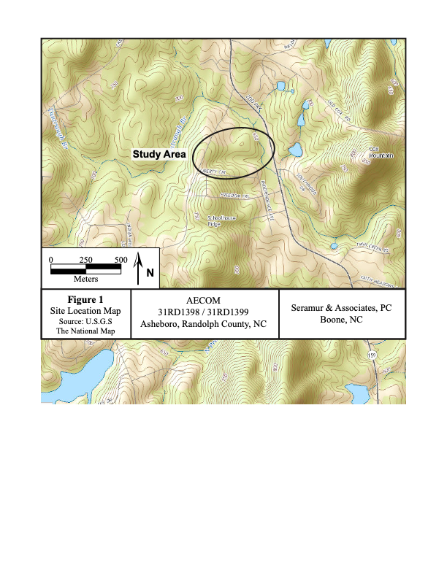

Figure . Topographic map of study area.

The geology and geomorphology of the landforms are described from geology maps, topographic maps, soil survey data and field observations (Figure 1). Soil profiles are described to record pedogenic horizons, lithology and stratigraphy. Each soil profile was described following standard soil taxonomy (Birkeland, 1999; and Schoeneberger et al., 1998).

## **Regional Geologic Setting of the Study Area**

The study area is located in the Carolina Terrane (formally referred to as Carolina Slate Belt) of central North Carolina. Bedrock at the two sites is mapped as felsic volcaniclastic rocks including tuff, lapilli tuff and tuff breccia with areas of felsic volcanic mudstone (Figure 2). A tuff is a cemented volcanic ash and the term lapilli is a term used to describe a tuff containing elongate or flattened disks of coarser clasts that were deposited within the finer grain ash tuffs. Breccia is a term used to describe a rock composed of angular fragments cemented together.

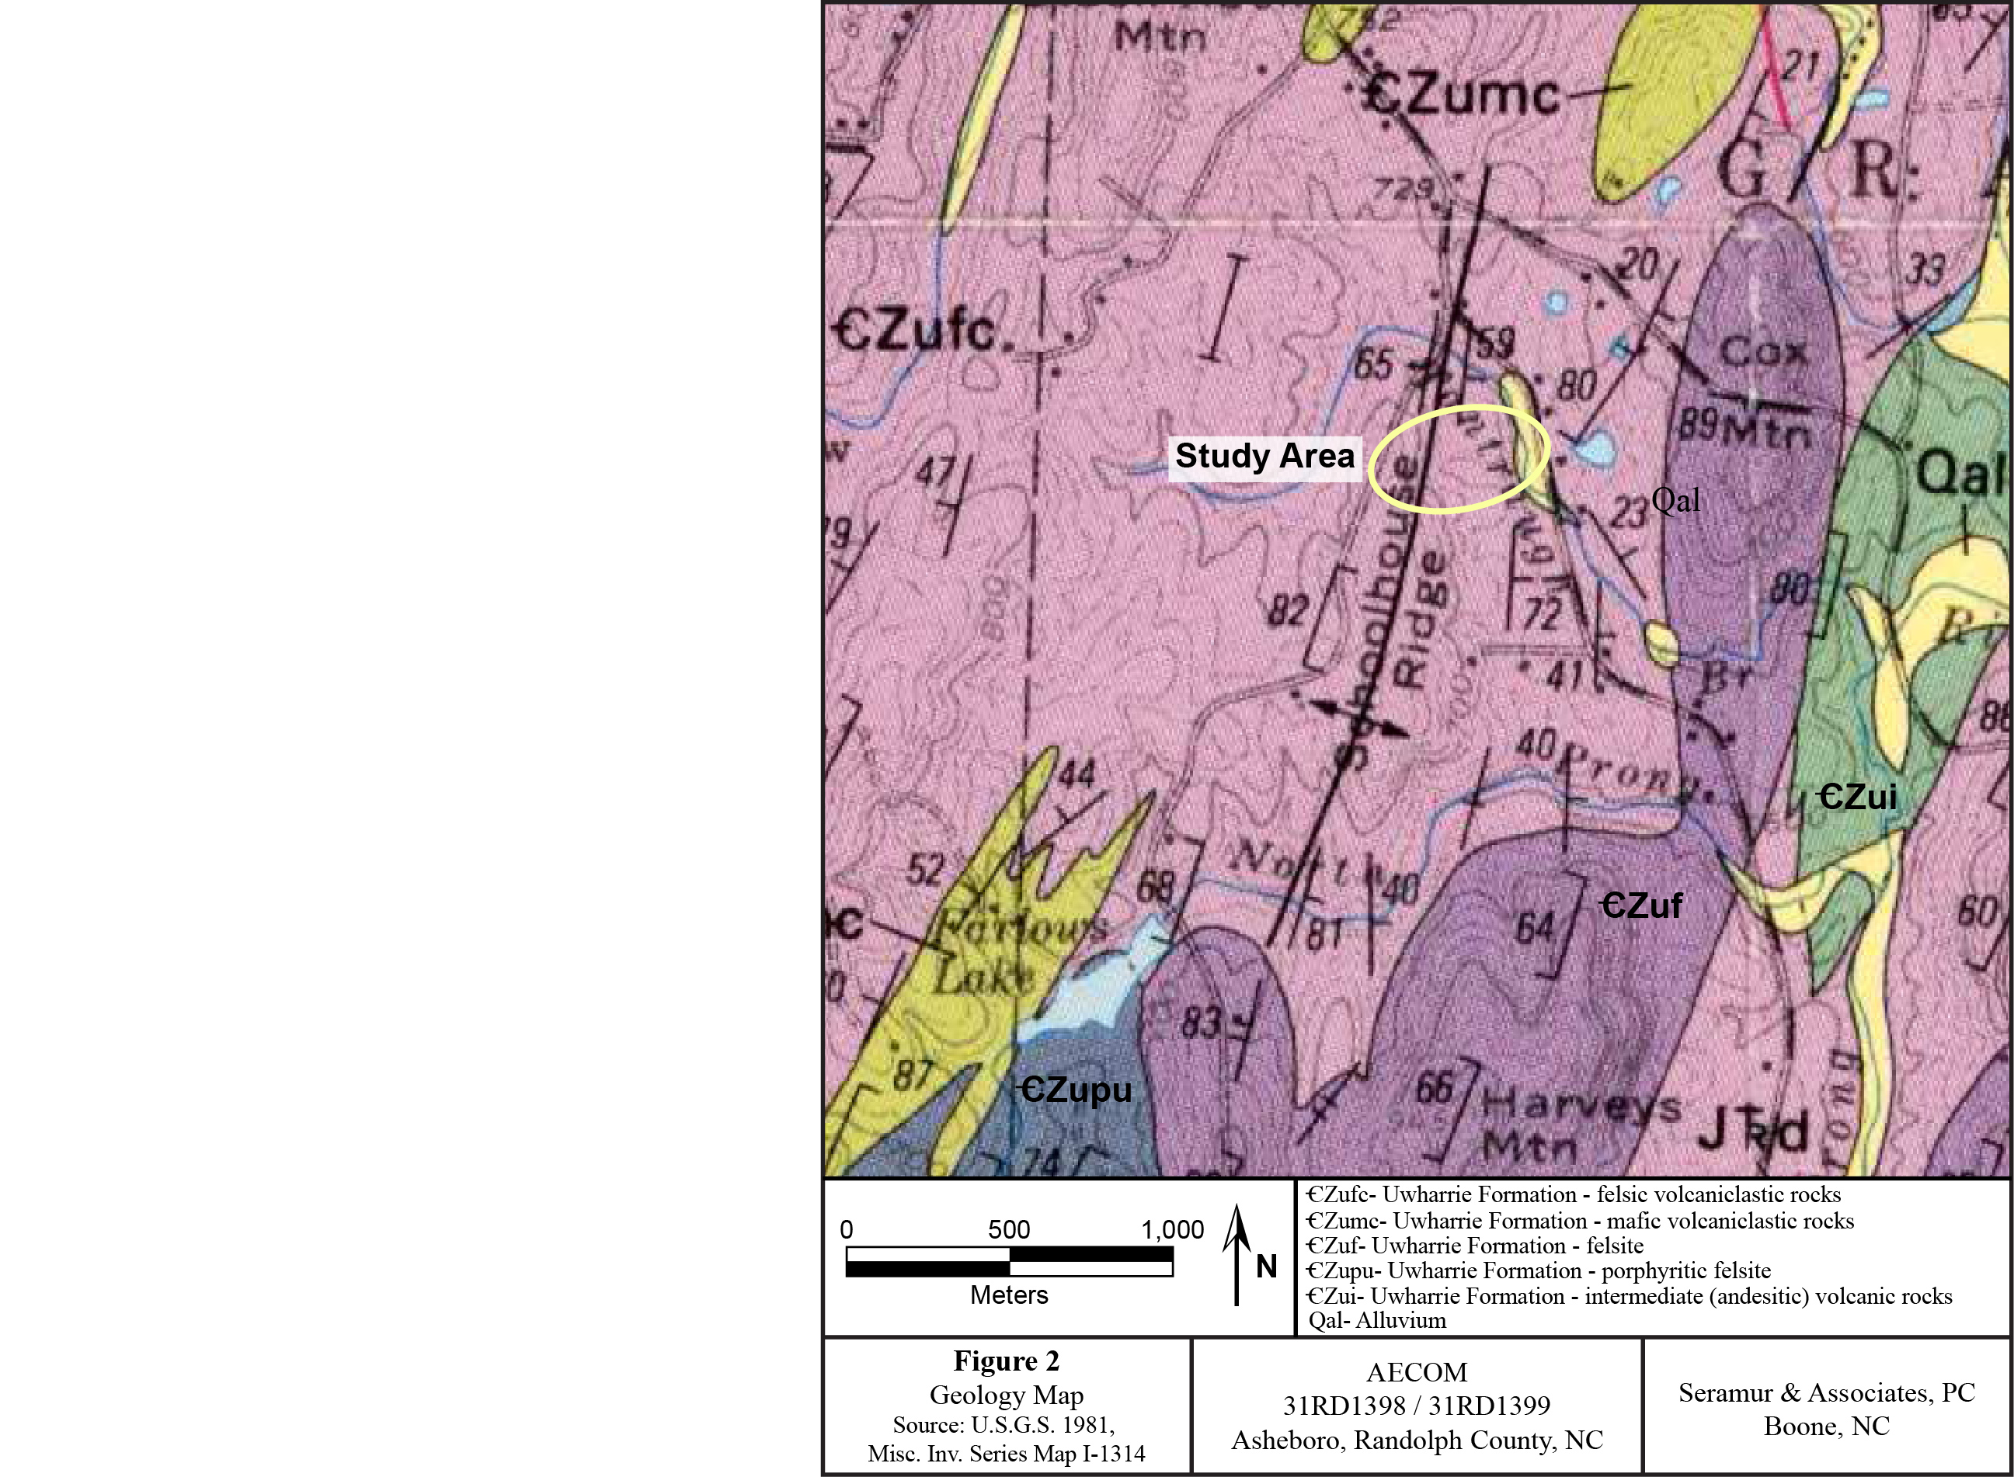

Figure . Geology map of the study area.

The study area extends from the crest of Schoolhouse Ridge down slope to Tantraugh Branch (Figure 1). The portion of Site 31RD1398 that was investigated includes the upper portion of the slope adjacent to an unnamed tributary that is fed from a spring located just below the ridge crest. Site 31RD1399 is located along the toe of the slope above Tantraugh Branch.

The soil units mapped at Sites 31RD1398 and 31RD1399 are the Georgeville silt loam and silty clay loam (GbC, GeB2 & GeC2) (Figures 3 and 4). The Georgeville soil unit is described as a plow zone over a Bt and C-horizon that extends to a depth of 80 inches (2 m). Parent material is described as residuum weathered from meta-volcanics and argillite.

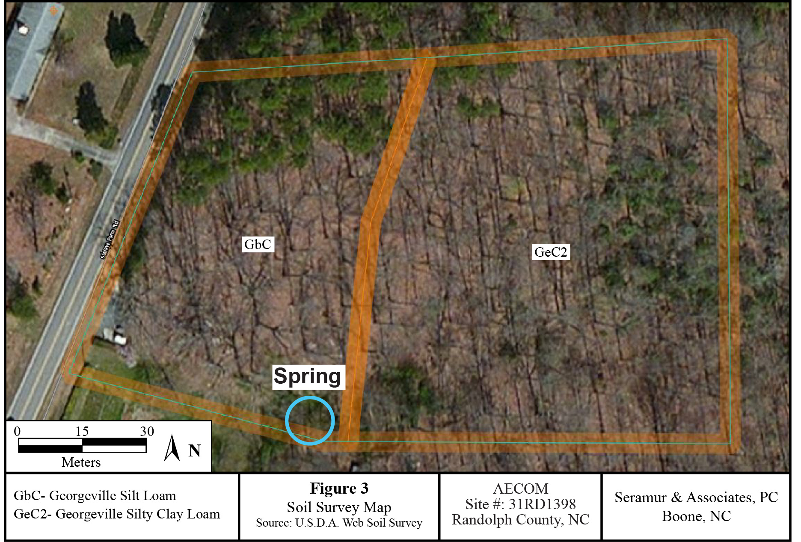

Figure . Soil survey map of Site 31RD1398.

The soil profiles described at these sites included A, E, Bw and Bt-horizons. An A-horizon is a mixture of organics and mineral grains. Transitional A/E-horizons are A-horizons that have undergone leaching as occurs in the E-horizon or zone of eluviation. These transitional horizons still contain some organics of the former A-horizon but also show properties of an E-horizon.

An E-horizon is a zone of eluviation or zone of leaching. Silt and clay are translocated down through the soil profile from the E-horizon into the B-horizon through the process of podzolization. The B-horizon is a zone of illuviation where silt and clay from the A- and E-horizons accumulate by adhering to the surfaces of sand grains. The clay particles in the B-horizons have negatively charged surfaces. Cations such as Fe+2 bind to the surface of these clay particles giving the B-horizon a reddish hue. A Bw-horizon is a weakly formed B-horizon where silt and clay have accumulated but where there has been little development of soil peds or soil structure. Bt-horizons have well developed soil peds with clay skins. The transition from a Bw-horizon to a Bt-horizon occurs over time and the degree of soil development can be used for relative dating of soils. The parent material at Site 31RD1398 is colluvium and at Site 31RD1399 it is colluvium and alluvium.

Profile Descriptions for Site 31RD1398

Site 31RD1398 is located on a slope adjacent to a drainage that extends up hill to a spring. The soil profiles at excavation Blocks A & C consist of a transitional A/E-horizon over an E-horizon (Figure 5). This E-horizon transitions into a Bt-horizon in the base of the profile. An outcrop of fine-grained, felsic metavolcanic bedrock protruded from the base of the excavation in Block A. This outcrop is surrounded by a halo of saprolite (weathered metavolcanics).

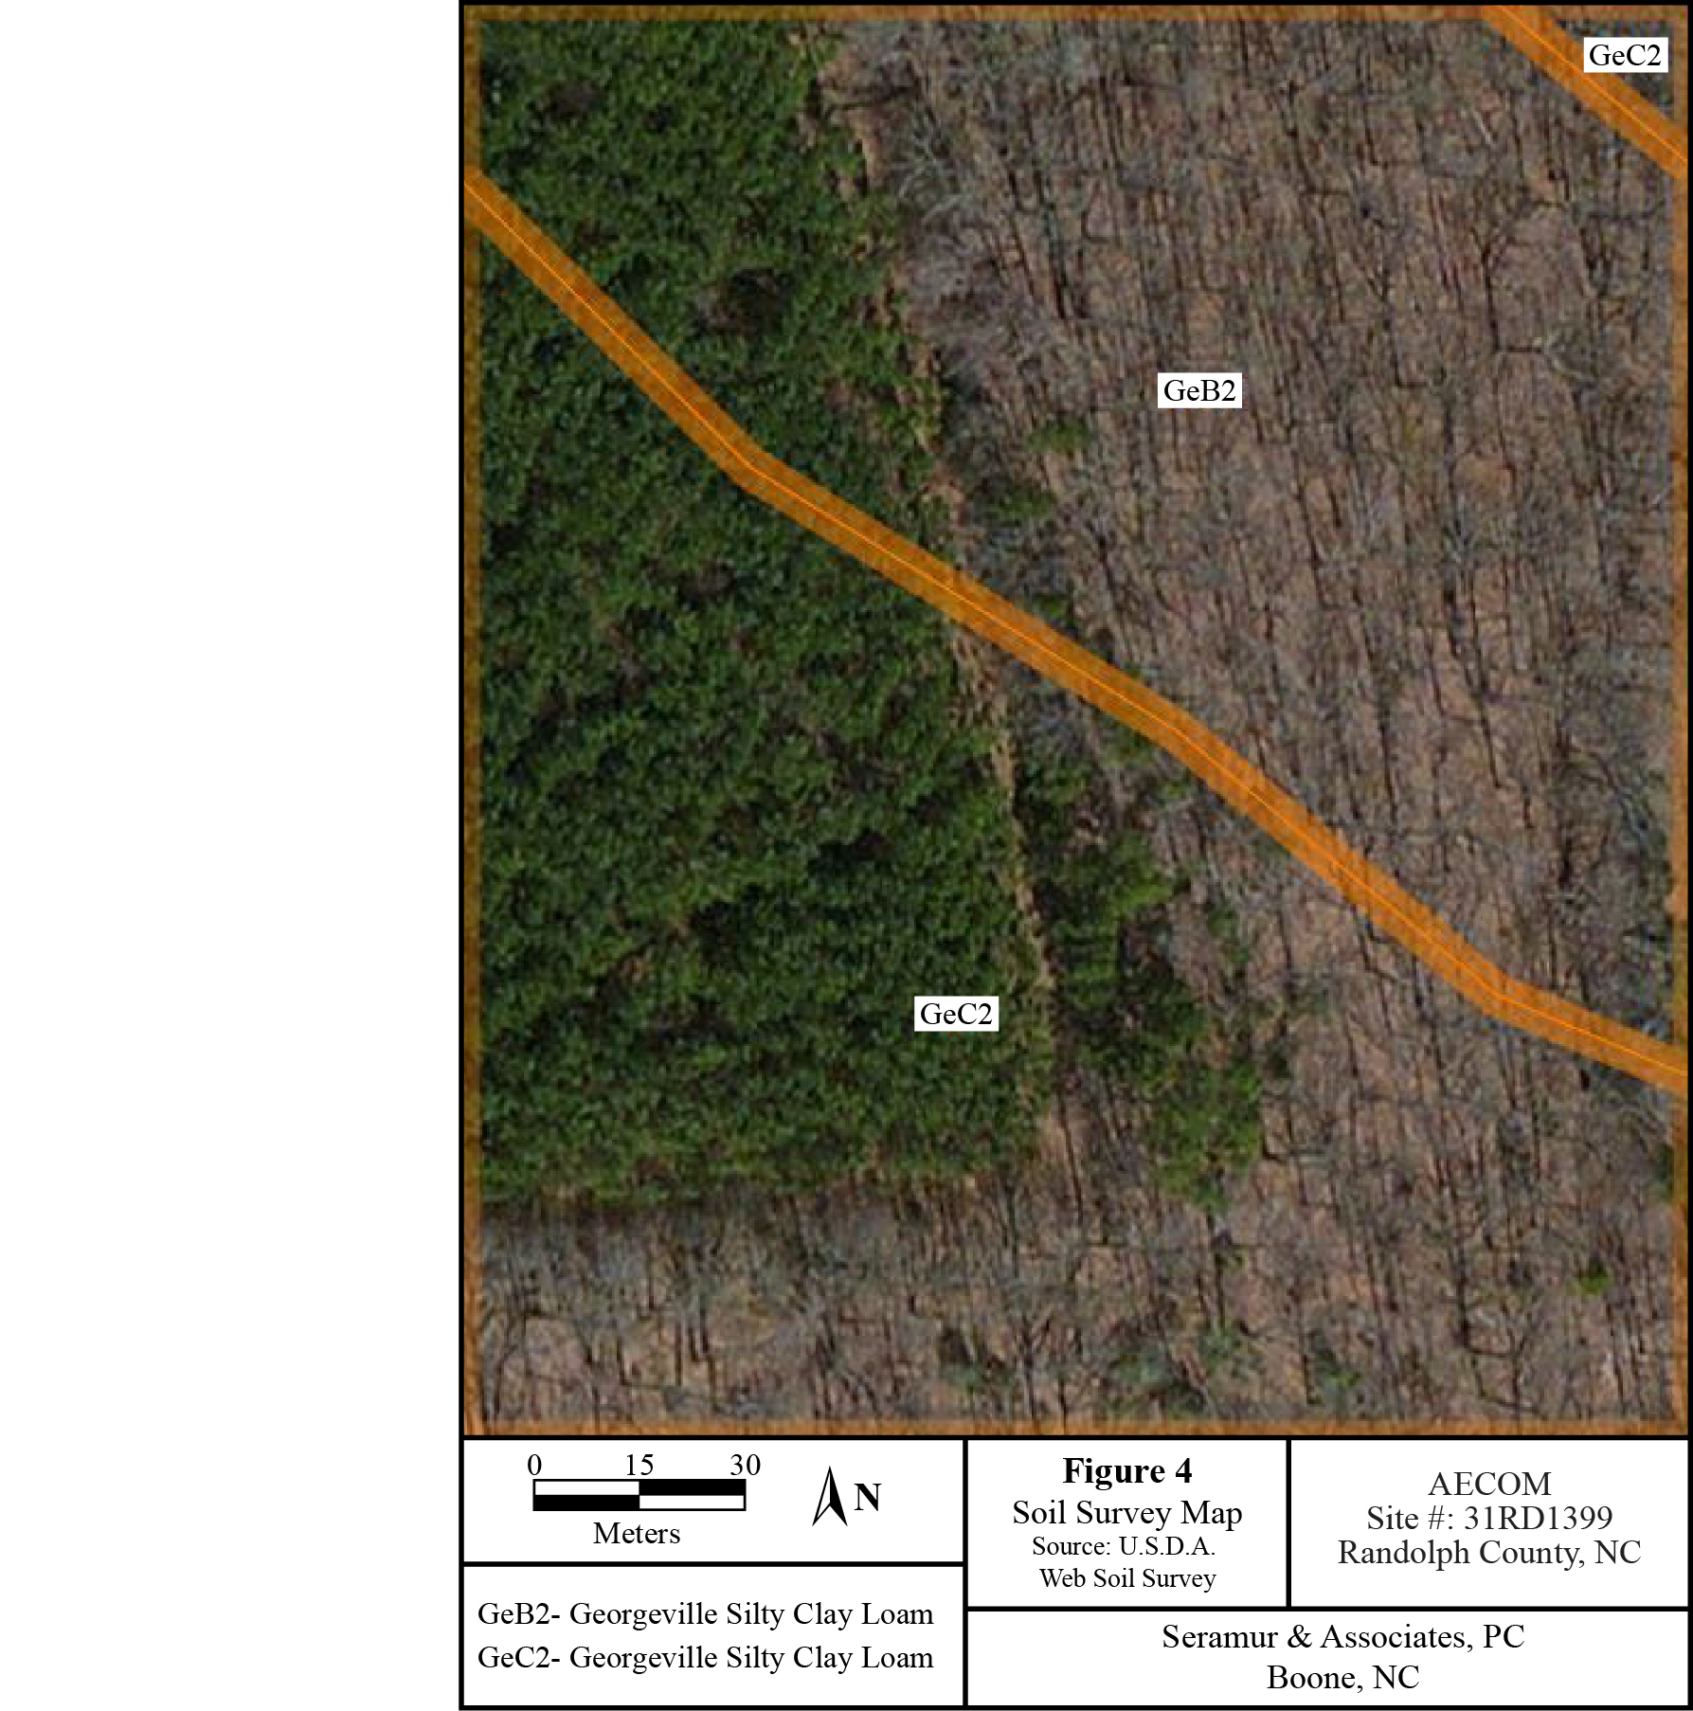

Figure 4. Soil survey map of Site 31RD1399.

The soil profile at excavation Block B consists of a very thin A-horizon (4 cm) over an E-horizon horizon (Figure 5). This E-horizon transitions into a Bt-horizon in the base of the profile. There is no A-horizon at the soil profile location for Block D. However, there are patches of A-horizon in other areas of the excavation block. The E-horizon in Block D transitions into a Bt-horizon in the base of the profile. The soil texture in the profiles described at Site 31RD1398 is silt loam at the surface that grades into a clay loam in the Bt-horizon. The lithic debitage and clasts in the E-horizon of excavation Block D is so dense that it forms a clast-supported deposit. This description is used when the clasts are in contact with each other rather than floating in a soil matrix. This lithic material included debitage as well as large quartz cobbles.

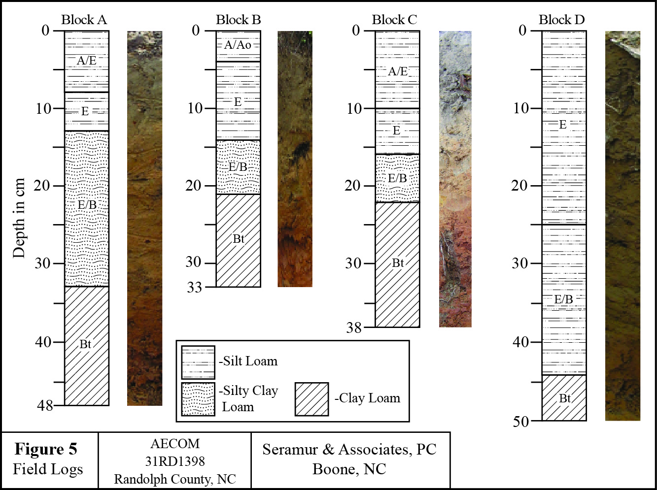

Figure 5. Field logs for excavation Blocks A through D.

Discussion of Site 31RD1398

An outcrop of aphanitic (fine-grained) metavolcanic bedrock was recorded in Block A and also observed near the spring head. The bed of the tributary stream is lined with metavolcanic cobbles and accumulations of these cobbles was observed in tree throws along the stream. It is likely that the drainage was lined with metavolcanic cobbles and boulders prior to European settlement in the area. Historic erosion has silted up the drainage so that cobbles are only exposed in the stream bed and in tree throws.

Sedimentary processes on the slope at Site 31RD1398 are limited to colluvial slope wash. The study area was reportedly plowed at one time, but plow scars were not observed in the soil profiles. Site 31RD1398 is located on an eroded Piedmont slope. The plow zone and most of the A-horizon has been eroded off of this slope. This is a residual soil so the artifacts recorded in the E-horizon were not buried by sedimentation, but most likely were bioturbated down into the profile over time. This means that the vertical context has been disturbed, but the horizontal distribution of the artifacts should be relatively intact.

Excavation Block D had a very high concentration of artifacts in the E-horizon. It was also furthest downslope. Slope wash would preferentially transport fine grain sediment down slope and leave coarse lithic debitage and cobbles behind. The high concentration of lithic material in the E-horizon of excavation Block D is attributed to erosion of surficial soil and over time, mixing of the lag deposit of artifacts into the E-horizon by bioturbation.

Profile Descriptions for Site 31RD1399

Site 31RD1399 is located on the toe slope and adjacent valley below Site 31RD1398. There is a relatively level tread or terrace that extends along the base of this slope. This is not an active alluvial terrace of Tantraugh Branch as it is 6.7 m (22 feet) above the stream. Excavation Blocks Y and W were excavated along the toe slope. The soil profile at excavation Block Y consisted of a thin A-horizon (4 cm) over an E-horizon (Figure 6). A Bw-horizon was recorded in the base of the profile. The A- and E-horizons are developed in a silt loam. The Bw-horizon is developed in a silt loam with gravel. The gravel content is very high and this is a clast supported deposit. This change in texture down the profile is very distinct.

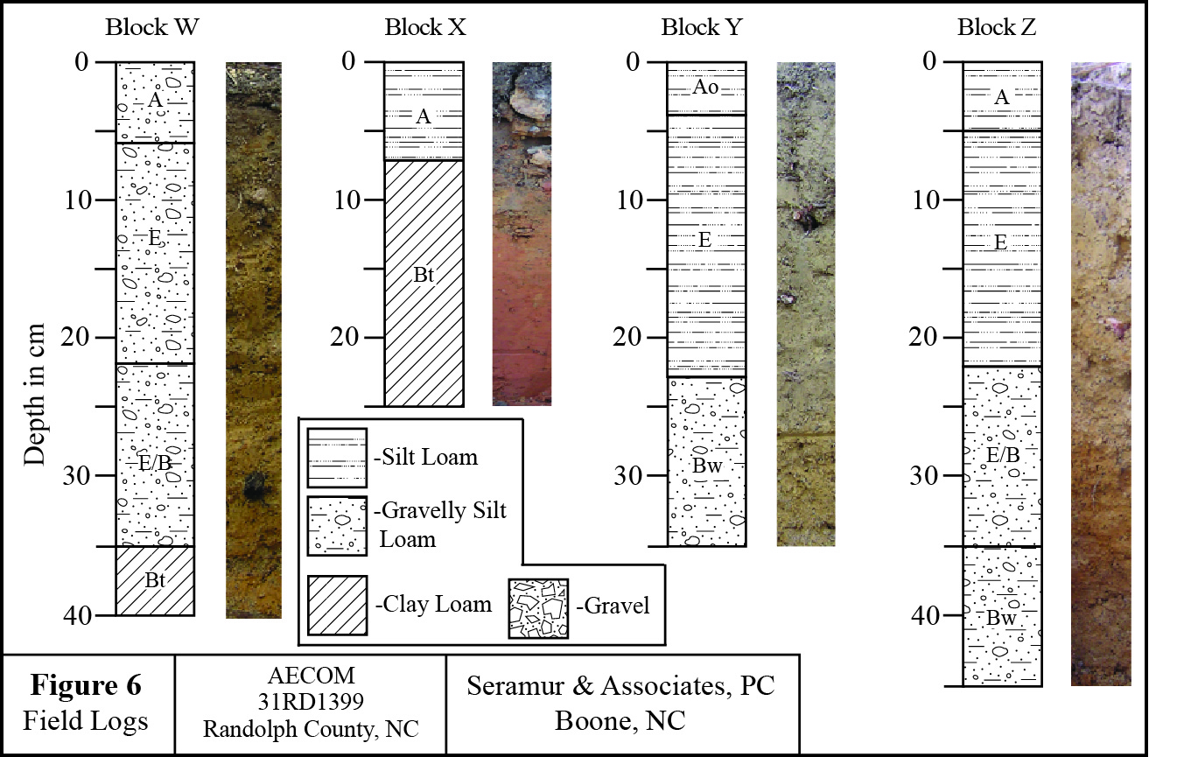

Figure 6. Field logs for excavation Blocks W through Z.

The soil profile at excavation Block W also consists of a thin A-horizon (6 cm) over an E-horizon horizon (Figure 6). This E-horizon transitions into a Bt-horizon in the base of the profile. This soil profile is developed in a silt loam with gravel.

Blocks X and Z were located on the northeastern portion of the terrace away from the valley slope. The soil profile at Block X was very thin with a 7 cm thick A-horizon above a well-developed Bt-horizon (Figure 6). The soil profile at excavation Block Z consists of an A-horizon over an E-horizon horizon (Figure 6). This E-horizon transitions into a Bt-horizon in the base of the profile. These soil profiles were developed in silt loam, clayey silt loam and gravelly silt loam.

Discussion of Site 31RD1399

Site 31RD1399 is located on a Pleistocene terrace of Tantraugh Branch. The climate of the Southeastern U.S. was much drier during the Late Glacial Maximum and river valleys in the southeast would have filled with sediment as the stream discharges were too low to transport the sediment downstream (Delcourt and Delcourt, 1985 and Cowan et al., 2015). This would allow elevated Pleistocene terraces to form well above the present stream channel. A warm and wet climate followed the Late Glacial Maximum at the end of the Pleistocene (Leigh, 2006). This wet climate allowed Tantraugh Branch to cut down through the Pleistocene alluvium to its present elevation and ending sedimentation on the elevated Pleistocene terrace.

There is a distinct change in the sediment texture in the soil profile at Block Y. The 23 cm of silt loam is probably not alluvial overbank sediment. This bed of fine-grained sediment is most likely slope wash deposits. The age of the slope wash deposits is not known. They could have accumulated throughout the Holocene or they could be historic sediment deposited since European settlement.

The sediment in excavation Blocks X and Z is interpreted to be Pleistocene alluvium. Buried cultural deposits would not be expected in this portion of the terrace because of the age of the alluvium. The gravelly deposits on this terrace indicate that Tantraugh Branch could have been a braided stream during the Late Glacial Maximum.

**Petrology of Lithic Artifacts and Raw Material Samples from 31RD1398 and 31RD1399**

Field Samples (Raw Materials) for Comparison with Artifact Samples

Raw Material samples collected from sites 31RD1398 and 31RD1399 sample the interbedded felsic metavolcanic and metasedimentary rocks of the Uwharrie formation.

Field samples and artifact samples are metamorphosed sedimentary rocks derived from weathering of preexisting volcanic materials and metamorphosed felsic volcanic rocks similar to those reported in Steponaitis et al., 2006 and Daniel and Butler, 1996. Samples investigated in this study are greenschist facies metamorphic rocks that contain relict primary sedimentary features such as graded bedding, clastic textures and sedimentary laminations and primary volcanic textures. Volcanic lithologies contain porphyritic, pyroclastic and aphyric textures composed of euhedral-subhedral phenocrysts, glomerocrysts, and apparent alignment of groundmass and phenocrysts, which shows flow orientation. Spherulitic-textured areas can be observed as fragments and within clasts in pyroclastic lithologies. Well-defined amygdules and glass shards were absent or not observed within these samples. Many of the volcaniclastic lithologies do contain polycrystalline aggregates of quartz that Stoddard (in Steponaitis et al., 2006) interpreted as possible quartz-filled amygdules. Volcaniclastic-textured samples are composed of varying volcaniclastic lithologies arranged within a single unit. Foliation, secondary minerals (epidote, biotite, chlorite and garnet) and slaty cleavage attest to the metamorphism experienced by these samples. Microfaults that offset primary sedimentary features, such as laminations, provide additional evidence for tectonic pressures and stresses associated with metamorphic events.

Mineralogical and textural features of artifact samples are described below to detail the lithologies and possible sources they could be derived from. Descriptions of the possible raw materials collected from different sites follow and a comparison of characteristics and features between each raw material sample collected are made with those observed from the artifact samples. A subsequent section details chemical analyses conducted at the University of Missouri Archaeometry laboratory by Michael Glascock. Subsequent interpretations of raw material and artifact provenance are assessed using statistical methods applied to the geochemical data collected from these studies on a subset of the samples.

Volcanic rock names for samples in this study are based on estimation of phenocrysts abundances from petrographic analysis using IUGS classification of volcanic rocks from Winter (2001). Provenance analysis of fine-grained metasedimentary samples is impeded by lack of chemical data.

|  |  |  |  |  |
| --- | --- | --- | --- | --- |
|  |  |  |  |  |

|  |  |  |  |  |
| --- | --- | --- | --- | --- |
| **Site Number** | **Field Sample** | **RM** | **Rock Type** | **Thin Section** |
| **31RD1398** | **110** | **1** | **Meta-tuff** | **Yes** |
| **31RD1398** | **111** | **2** |  |  |
| **31RD1398** | **112** | **3** |  |  |
| **31RD1398** | **113** | **4** | **metasandstone** | **Yes** |
| **31RD1398** | **114** | **5** | **Meta-tuff** | **Yes** |
| **31RD1398** | **115** | **6** | **Meta-tuff** | **Yes** |
| **31RD1398** | **116** | **7** | **Meta-tuff** | **Yes** |
| **31RD1398** | **117** | **8** | **Meta-tuff** | **Yes** |
| **31RD1398** | **202** | **9** |  |  |
| **31RD1398** | **265** | **9** | **Meta-siltstone** | **Yes** |
| **31RD1398** | **454** | **10** | **Meta-siltstone** | **Yes** |
| **31RD1398** | **456** | **11** |  |  |
| **31RD1398** | **452** | **12** |  |  |
| **31RD1399** | **453** | **13** | **Tuffaceous sandstone** | **Yes** |
| **31RD1399** | **455** | **14** | **Meta-siltstone** | **Yes** |
| **31RD1399** | **458** | **15** | **Meta-siltstone** | **Yes** |
| **31RD1398** | **457** | **16** | **Meta-siltstone** | **Yes** |
|  |  |  |  |  |
| **31RD1398** |  | **Type A** | **Meta-siltstone** |  |
| **31RD1398** |  | **Type B** | **Meta-siltstone** | **Yes** |
| **31RD1398** |  | **Type C** | **Meta-siltstone** | **Yes** |
| **31RD1398** |  | **Type D** | **Meta-siltstone** | **Yes** |
| **31RD1398** |  | **Type E** | **Meta-siltstone** | **Yes** |
| **31RD1398** |  | **Type F** | **Meta-trachyte** | **Yes** |
| **31RD1399** |  | **Type W** | **Meta-siltstone** | **Yes** |
| **31RD1398** | **108.5** | **Type X** | **Meta-siltstone** | **Yes** |
| **31RD1399** | **440** | **Type Y** | **Meta-siltstone** | **Yes** |
| **31RD1399** | **309.3** | **Type Z** | **Meta-siltstone** | **Yes** |

**Table 1. Asheboro Bypass Samples.**

Artifact Samples (set 1)

The artifact samples consist of fine-grained, foliated metasedimentary rocks some of which have sedimentary laminations. Due to their fine-grain size, clastic texture is difficult to assess. Cross laminations and graded bedding were observed in a number of samples. Additionally, these samples have a much higher modal abundance of epidote, which defines the foliation. The mineralogical similarities these samples share with regional volcanic rocks suggests these samples were derived from reworking of volcanic ash deposits. Samples 1, 2 & 3 both contain wavy laminations and show the ovoid features. Sample 4 contains graded bedding and sample 5 contains very fine laminations.

FS20-AS1

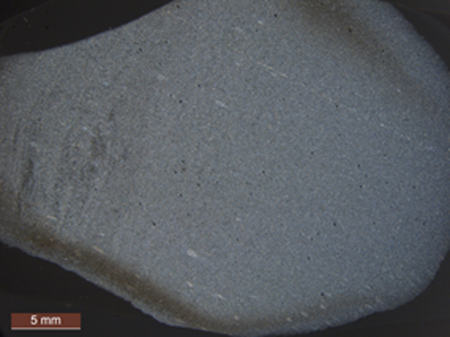

**Figure 7. Cross polarized light overview of sample FS20-AS1.**

FS20-AS1 is dark grey with darker grey wavy cross-laminations in hand specimen. The sample contains laminations which are oblique to foliation. Foliation is defined by the long axis of epidote crystals. The sample is composed of fine-grained (avg. dia. 23µm) plagioclase, quartz, epidote, clinozoisite and garnet. The sample contains small (~0.5mm) ovoid features filled with quartz grains. The long axis of the features is parallel to laminations. These ovoid features may represent smaller grains undergoing recrystallization into larger grains or heterogeneity in the sediment source prior to metamorphism. The sample also contains one thin (<1µm) quartz vein that cuts parallel to foliation; however it does not appear to offset laminations within this sample. Based upon the laminations, foliation and metamorphic minerals, this sample is a metasiltstone. As a metasiltstone, this sample could be correlative with those from the Chatham Pittsboro Quarry of Steponaitis et al (2006).

FS20-AS2

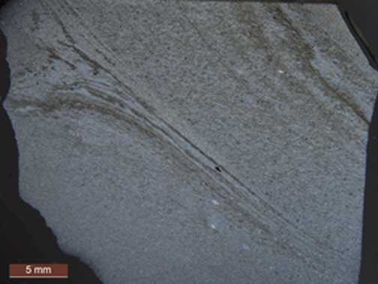

**Figure 8. Cross polarized light overview of sample FS20-AS2.**

FS20-AS2 is dark brownish-grey and contains lighter grey bands in hand specimen. The sample contains wavy cross laminations that are parallel to foliation. Some laminae in the sample are much darker giving a portion of the sample a banded appearance in hand specimen and thin section. The sample is composed of fine-grained, elongated (avg. dia. 28µm) quartz, plagioclase, muscovite, epidote, garnet + opaques (FeS2). The sample contains small (~0.5mm) ovoid features filled with quartz grains. The long axis of the features is parallel to laminations. The ovoid features may represent small devitrified ash particles, smaller sand-sized grains that are undergoing recrystallization or heterogeneity in the sediment source prior to metamorphism. Based upon the laminations, fine grain size, foliations and metamorphic mineralogy, this sample is a metasiltstone. This sample may correlate to those from the Person, Chatham Pittsboro or Chatham Siler Quarries described by Stoddard in Steponaitis et al (2006). Due to the presence of cross laminations, this sample is better correlated to those from the Chatham Pittsboro and Person County Quarries.

FS20-AS3

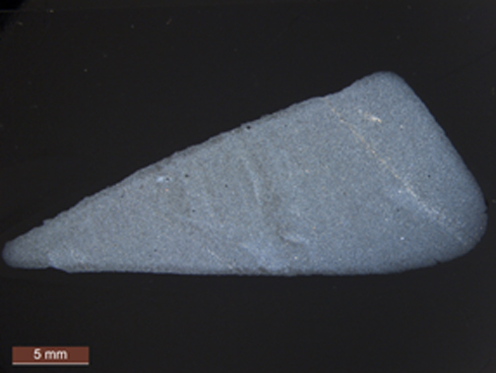

**Figure 9. Cross polarized light overview of sample FS20-AS3.**

Sample FS20-AS3 is greyish-brown in hand sample. The sample contains relict cross laminations that are apparent in hand specimen and in thin section. The sample is composed of fine-grained (avg. dia. 29µm) irregular-equant-shaped grains quartz. Epidote, garnet, and fine-grained clinozoisite are weakly aligned to form a foliation. The sample shows several thin quartz veins and several small ovoid features of recrystallized quartz. The long axis of these ovoid features is oblique to laminations. The origin of ovoid features is uncertain, as they appear to disrupt laminae and have no mineralogical or textural differences from the surrounding rock. These ovoid features may represent heterogeneity in the sediment source prior to metamorphism. Based upon the primary textural features (sedimentary laminations), grain size, foliation and metamorphic minerals, this sample is a metasiltstone. This sample may be correlative to those from the Person, Chatham Pittsboro or Chatham Siler Quarries described by Stoddard in Steponaitis et al (2006). Due to the presence of cross laminations, this sample is better correlated to those from the Chatham Pittsboro and Person County Quarries.

FS20-AS4

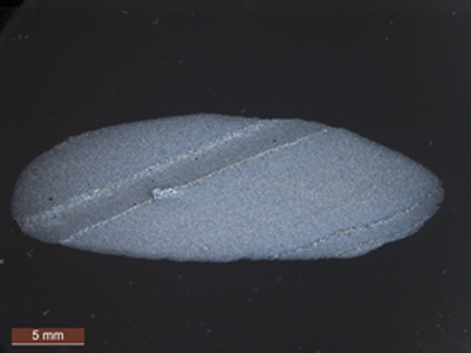

**Figure 10. Cross polarized light overview of sample FS20-AS4.**

In hand specimen, FS20-AS4 is a dark grey with distinctive light grey colored bands. The sample contains laminae defined by coarsening in grain size, which is interpreted as graded bedding. The sample is fine-grained (grain size ranges from 20-72µm) and is composed of a foliated assemblage of quartz, plagioclase, epidote muscovite, very fine-grained chlorite and garnet. Foliation is parallel to laminae and graded bedding within this sample. Based on presence of graded bedding, laminations, foliation, and metamorphic mineralogy, this sample is a metasiltstone. This sample may be correlative to those from the Person, Chatham Pittsboro or Chatham Siler Quarries described by Stoddard in Steponaitis et al (2006). However, due to the presence of sedimentary features such as laminations and graded bedding, the Chatham Pittsboro and Person Quarries are a better source comparison.

FS20-AS5

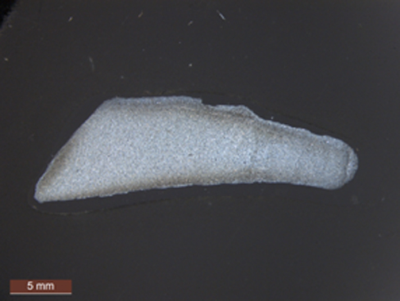

**Figure 11. Cross polarized light overview of sample FS20-AS5.**

FS20-AS5 is dark grey in hand specimen. The sample shows weak laminations oblique to foliation. One portion shows a clastic texture, but the majority of the thin section is too fine-grained to observe this texture. The sample is composed of fine-grained (avg. dia. 24µm) quartz, epidote, garnet and muscovite. Based on limited textural evidence (weak laminations and grain size changes parallel to them), metamorphic mineralogy and foliation, this sample is a metasiltstone. This sample may be correlative to those from the Person, Chatham Pittsboro or Chatham Siler Quarries described by Stoddard in Steponaitis et al (2006).

Raw Material Samples

Within the raw materials collected from field samples 110-458, two were characterized as reworked volcaniclastic sedimentary rocks, three as lapilli tuffs and three additional samples as fine-grained sedimentary rocks resulting from erosion and reworking of volcanic rocks prior to metamorphism.

Within the sample suite from RM-9, the feature and Type samples A-E all contain primary sedimentary features, which indicate these rocks are metasedimentary rocks and the fine grain sizes constrain them as being metasiltstones. It is possible some of these represent fine-grained ash tuffs, however volcanic features were absent in these samples. These samples all share very similar greenschist facies mineralogy. Some of these samples also contain ovoid features that Stoddard interpreted as either fecal pellets or trace fossils. Ovoid features within these samples lack the dark rim material observed by Stoddard (Steponaitis et al., 2006) and are interpreted as sedimentary heterogeneities or volcaniclastic materials.

FS110-RM1

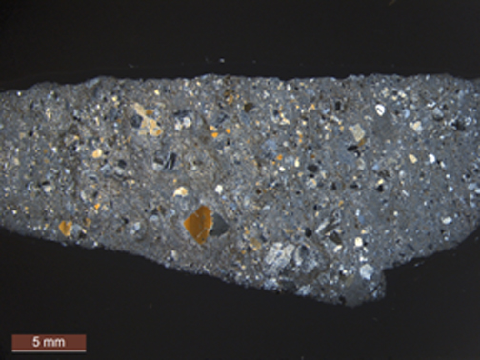

**Figure 12. Cross polarized light overview of sample FS 110-RM-1.**

FS 110-RM1 is mottled grey and porphyritic textured in hand specimen with a light grey weathered surface. The sample has a pyroclastic texture composed of lapilli with porphyritic (some have spherulites) to aphyric clasts, euhedral to subhedral plagioclase (some of which contains clinozoisite from saussuritization), quartz phenocrysts which constitute ~ 10% of sample (avg. dia. 676µm and some phenocrysts are up to 3.5mm in long dimension) and glomerocrysts of quartz and plagioclase. Additional minerals are epidote, chlorite, muscovite, and minor stilpnomelane. Based upon textures and mineralogy (~25 vol% of quartz), this sample is a dacitic crystal-lithic metatuff. Texturally, this sample corresponds to those collected from the Uwharries Eastern, Uwharries Asheboro, Chatham Silk Hope, Chatham Siler City or Orange County Quarries of Steponaitis et al (2006). Alternatively, this sample may have been collected from an unknown site that samples the Tillery formation. As a distinctive volcanic lithology, this sample bears no strong resemblance to the artifact samples collected.

FS113-RM4

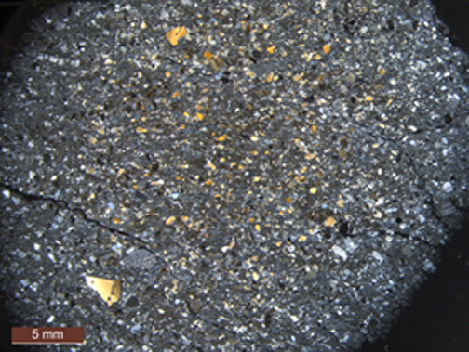

**Figure 13. Cross polarized light overview of sample FS 113-RM-4.**

FS113-RM4 is light orangish-brown in color and fine-grained in hand specimen. In thin section, sample shows a porphyroclastic texture composed of a heterogeneous mixture of volcanic rock fragments and subhedral-anhedral phenocrysts and phenocryst fragments of plagioclase feldspar and quartz (some of which show embayments). Additional minerals are epidote, green biotite and chlorite. This sample is a dacitic tuffaceous metasandstone. There is no visible bedding or sorting observed in this sample. This sample bears the strongest resemblance to the samples collected from the Durham County Quarry of Steponaitis et al (2006). As a distinctive medium grain-sized volcaniclastic lithology, this sample bears no resemblance to the artifact samples collected.

FS114-RM5

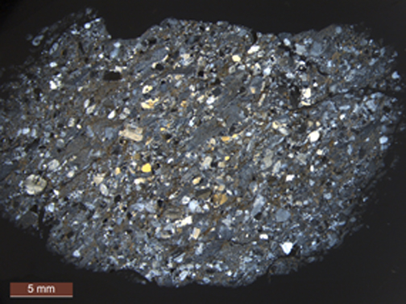

**Figure 14. Cross polarized light overview of sample FS 114-RM-5.**

FS114-RM5 is light orangish-brown-colored and medium-grained in hand specimen. The hand sample shows heterogeneous mixture of crystals and clasts showing parallel arrangement according to foliation. The sample has a pyroclastic texture composed of lapilli (avg. dia. 2.5mm) with porphyritic (some containing spherulites) to aphyric textures and phenocrysts (avg. dia. 751µm which constitute ~ 20% of the sample) of plagioclase, quartz. Additional minerals are biotite, epidote and chlorite. Quartz also occurs as polycrystalline aggregates and may represent amygdules. Based upon textures and mineralogy (~30 vol% quartz), this sample is a dacitic crystal-lithic metatuff. Texturally, this sample corresponds to those collected from the Uwharries Eastern, Uwharries Asheboro, Chatham Silk Hope, Chatham Siler City or Orange County Quarries of Steponaitis et al (2006). Alternatively, this sample may have been collected from an unknown site that samples the Tillery formation. Again, as all artifact samples are fine-grained metasedimentary rocks, this sample does not provide a good match as a raw material used in creation of the collected artifacts.

FS115-RM6

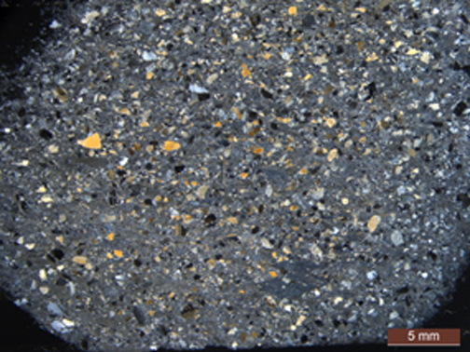

**Figure 15. Cross polarized light overview of sample FS 115-RM-6.**

FS115-RM6 is light orangish-brown-colored and medium-grained in hand specimen. Hand sample shows heterogeneous mixture of crystals and clasts showing parallel arrangement according to foliation. The sample has a pyroclastic texture composed of lapilli (up to 5.9mm) with porphyritic to aphyric textures and phenocrysts (avg. dia. 616µm which constitute ~ 25% of the sample) of plagioclase, quartz. Additional minerals are biotite, epidote and chlorite. Quartz also occurs as polycrystalline aggregates. Based upon textures and mineralogy (~30 vol% quartz), this sample is a dacitic crystal-lithic metatuff. Texturally, this sample corresponds to those collected from the Uwharries Eastern, Uwharries Asheboro, Chatham Silk Hope, Chatham Siler City or Orange County Quarries of Steponaitis et al (2006). Alternatively, this sample may have been collected from an unknown site that samples the Tillery formation. Again, as all artifact samples are fine-grained metasedimentary rocks, this sample does not provide a good match as a raw material used in creation of the collected artifacts.

FS116-RM7

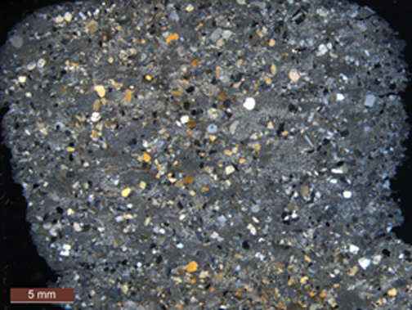

**Figure 16. Cross polarized light overview of sample FS 116-RM-7.**

FS116-RM7 is light orangish-grey in color and is fine-medium-grained in hand specimen. The sample displays a pyroclastic texture composed of a heterogeneous mixture of crystals and of aphyric to porphyritic textured clasts (some of which contain spherulites) showing parallel arrangement according to foliation. Phenocrysts (avg. L.D. 554µm, constitute up to 10% of sample) of embayed quartz, euhedral – subhedral plagioclase feldspar and possible amygdules filled with quartz. Additional minerals are chlorite, stilpnomelane, biotite, garnet and clinozoisite. Based upon textures and mineralogy (~25 vol% quartz), this sample is a dacitic crystal-lithic metatuff. Texturally, this sample corresponds to those collected from the Uwharries Eastern, Uwharries Asheboro, Chatham Silk Hope, Chatham Siler City or Orange County Quarries of Steponaitis et al (2006). Alternatively, this sample may have been collected from an unknown site that samples the Tillery formation. Artifact samples are all fine-grained metasedimentary rocks and no correlation can be made using this lithology as a raw material to create these artifacts.

FS117-RM8

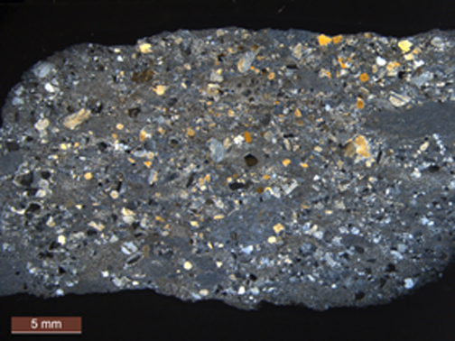

**Figure 17. Cross polarized light overview of sample FS 117-RM-8.**

FS117-RM8 is light orangish-grey in color and is fine-medium-grained in hand specimen. The sample displays a pyroclastic texture composed of aphyric to porphyritic textured clasts (some of which contain spherulites) and phenocrysts (avg. L.D.1.05mm, constitute up to 10% of sample) of embayed quartz, euhedral – subhedral plagioclase feldspar and possible amygdules filled with quartz. Additional minerals are chlorite, stilpnomelane, biotite, garnet and clinozoisite. Based upon textures and mineralogy (~25 vol% quartz), this sample is a dacitic crystal-lithic metatuff. Texturally, this sample corresponds to those collected from the Uwharries Eastern, Uwharries Asheboro, Chatham Silk Hope, Chatham Siler City or Orange County Quarries of Steponaitis et al (2006). Alternatively, this sample may have been collected from an unknown site that samples the Tillery formation. Artifact samples are all fine-grained metasedimentary rocks and no correlation can be made using this lithology as a raw material to create these artifacts.

FS265 RM9 Feature 1

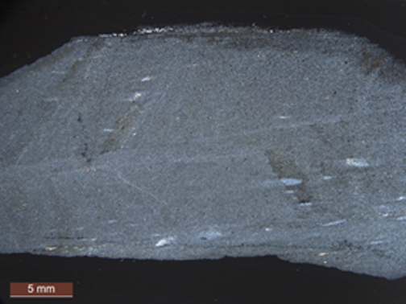

**Figure 18. Cross polarized light overview of sample FS 265-RM-9.**

In hand specimen RM-9 Feature 1, the sample is brownish-grey and shows laminations that are displaced along a fault. The weathered exterior is light grey with orange oxidation staining. RM-9 Feature 1 is composed of fine-grained (avg. dia. 29µm) deformed (elongated) quartz, plagioclase chlorite, garnet and opaques and displays relict laminations oblique to foliation. Aligned epidote and elongated quartz and plagioclase crystals define the foliation. The sample contains up 3mm (L.D.) ovoid features composed of quartz and minor amounts of chlorite. The origin of ovoid features is uncertain, as they appear to disrupt laminae and have no mineralogical or textural differences from the surrounding rock. These ovoid features may represent possible pumice clasts or heterogeneity in the sediment source prior to metamorphism. The ovoid areas do not contain the same dark rims detailed by Stoddard (Steponaitis et al, 2006). Based upon the laminations, foliated texture and metamorphic minerals, this sample is a metasiltstone. Sample RM-9 has similar characteristics to rocks collected from the Person County, Chatham Pittsboro and Chatham Siler City Quarries of Steponaitis et al (2006). Of the characteristics observed, it may be best correlated with samples from the Person County Quarry based upon the ovoid inclusions, bedding and micro-faults. These features are absent from the artifact samples. The grain size of this sample falls within the range of those from the artifact sample suite and it does have the distinctive laminations. It is possible that due to the small sample size of the of artifact samples that the micro-faults and ovoid features were not sampled.

FS454-RM10

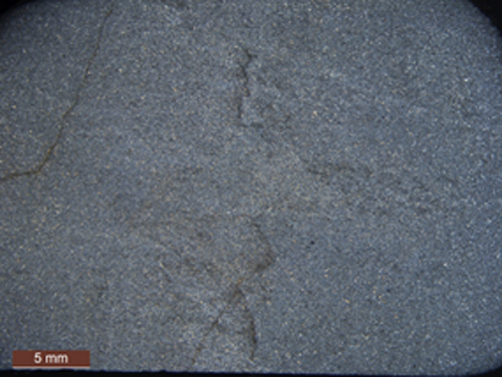

**Figure 19. Cross polarized light overview of sample FS 454-RM-10.**

In hand specimen, FS454-RM10 is mottled dark brownish grey with a light grey weathered surface and contains disrupted laminations that are offset by micro-faults. The sample has a clastic texture composed of fine-grained (avg. dia. 35µm) irregular-shaped grains of quartz, plagioclase, epidote, chlorite, muscovite and biotite. The sample shows very poor bedding which may result from micro-faults. The sample has a foliation defined by alignment of epidote crystals that is oblique to laminations. The laminations, clastic texture, foliation, metamorphic minerals and grain size indicate this is a metasiltstone. Based on observations by Stoddard in Steponaitis et al (2006), this sample may be representative of one of the metasiltstone lithologies collected from the Chatham Pittsboro, Chatham Siler City or Person County Quarries. The faults offsetting laminae are a distinctive feature that best correlates with observations of the metasedimentary rocks from the Person Quarry. The artifact samples share bedding as a similarity, but none, perhaps due to smaller sample size showed the offset lamination contained within this sample. While this sample shares similar mineralogy with artifact samples, grain size differences and the lack of distinctive bedding features militate a relationship between this raw material and the artifact samples.

FS453-RM13

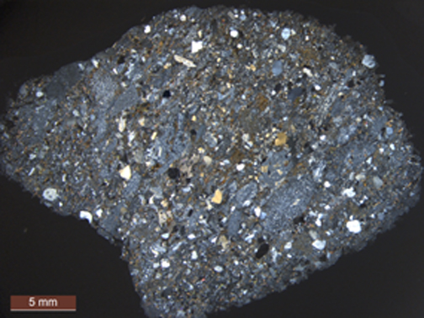

**Figure 20. Cross polarized light overview of sample FS 453-RM-13.**

FS 453-RM13 is dark greenish-grey in hand specimen. The sample has a pyroclastic texture composed of phenocrysts (avg. dia. 739µm-which constitute up to 10% of the sample) of plagioclase, quartz and embayed quartz, rare spherulitic-textured clasts, glomerocrysts, fine-grained porphyritic to aphyric clasts, flow-banded (trachytic) clasts with some mafic minerals, devitrified aphyric clasts, ellipsoidal clasts interpreted to be amygdules containing epidote and calcite and recrystallized quartz clasts showing equilibrium textures. Metamorphic minerals are epidote, clinozoisite, biotite and calcite. The sample also contains polycrystalline aggregates of quartz, which might be quartz-filled amygdules. Plagioclase shows saussuritization. Based upon mineralogy (~25 vol% quartz), lithologic diversity and metamorphic minerals this sample is a dacitic tuffaceous sandstone. This sample bears similarities with the Chatham Silk Hope, Chatham Siler City, and the Uwharries West Quarries of Steponaitis et al (2006). Artifact samples are too fine grained and have sedimentary origins to consider this lithology as a candidate raw material.

FS455-RM14

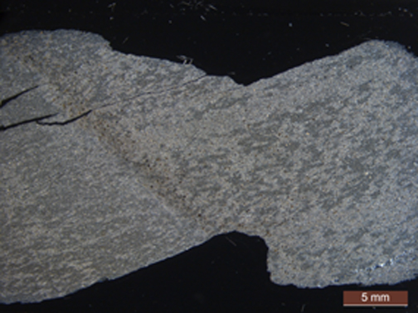

**Figure 21. Cross polarized light overview of sample FS 455-RM-14.**

Sample FS455-RM14 is light grey and foliated in hand specimen. Thin section shows that the sample is fine-grained (avg. dia. 44 and 56µm) and weakly laminated parallel to foliation. The section appears to sample two similar lithologies separated by coarser-grained (up to 80µm in L.D.) epidote. Laminae are composed of fine discontinuous layers of plagioclase, quartz, epidote, and muscovite. Some laminae in the sample are much darker giving a portion of the sample a banded appearance in hand specimen and thin section. Grains have angular shapes and are randomly distributed in irregular orientations throughout the thin section. Plagioclase shows saussuritization texture. Epidote, biotite, and chlorite define a weak foliation. The sample lacks features that constrain its origin as sedimentary or igneous. Based on the clastic texture, metamorphic minerals, foliation and grain size, this is a metasiltstone. Based upon the lithology, this sample might be correlated to those collected from the Chatham Pittsboro Quarry and detailed by Stoddard in Steponaitis et al, 2006. The lack of coherent laminations in this raw material sample, its larger grain size and mottling do not match any of the characteristics of the artifact samples.

FS458-RM15

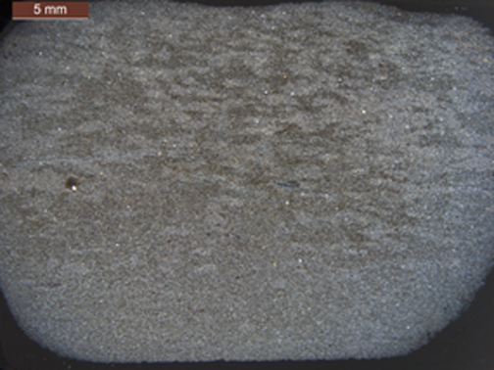

**Figure 22. Cross polarized light overview of sample FS 458-RM-15.**

FS458-RM15 is greyish-green in hand specimen with a lighter greenish-grey weathered surface. Thin section shows FS458-RM15 has a mottled clastic texture and is composed of fine-grained (avg. dia. 50µm), plagioclase, quartz, biotite, titanite, chlorite, clinozoisite and epidote. Grains have angular shapes and are randomly distributed in irregular orientations throughout the thin section. Plagioclase shows saussuritization texture. Epidote, biotite, and chlorite define a weak foliation. Aside from heterogeneous grain sizes (avg. grain size 50µm+/-40.01, N=19), the sample appears to contain graded bedding that helps to constrain its origin as sedimentary. Based on the clastic texture, graded bedding, metamorphic minerals, foliation and grain size, this is a metasiltstone. Based upon the lithology and color, this sample might be correlated to those collected from the Chatham Pittsboro Quarry and detailed by Stoddard in Steponaitis et al, 2006. The lack of coherent laminations in this raw material sample, its larger grain size and mottling do not match any of the characteristics of the artifact samples.

FS457-RM16

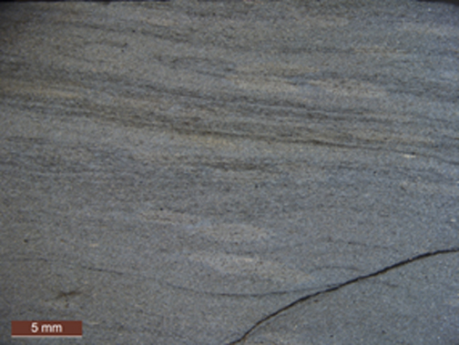

**Figure 23. Cross polarized light overview of sample FS 457-RM-16.**

Sample FS457-RM16 is dark grey and cross laminated in hand specimen. Thin section shows that the sample is fine-grained (avg. dia. 32µm) and laminated parallel to foliation. Laminae are composed of fine and finer layers of plagioclase, quartz, epidote, subhedral garnet and muscovite. Some laminae in the sample are much darker giving a portion of the sample a banded appearance in hand specimen and thin section. Based on grain size differences within this sample, laminations, metamorphic minerals and foliation, this sample is a metasiltstone. A lack of chemical data and the fine-grained nature of this sample make it difficult to determine a provenance for the sediment. Laminae, bedding and dark color of this sample appears to be a suite of distinctive characteristics that could correlate them to one of the quarries, but these features were not well detailed in the petrographic report by Stoddard in Steponaitis et al, (2006), however chemical analysis would provide additional information about alkali content that could further constrain the origin of this sample to a specific quarry. Based on the distinctive bedding, it correlates best with artifact samples 2 and 4; however, it lacks the graded bedding seen in artifact sample 4. This raw material sample has a slightly larger grain size than most of the artifact samples (21-29µm). The mineralogy between this sample and the artifact samples is similar, but the banded laminated appearance provides the strongest match between this raw material sample and artifact sample 2.

Artifact Samples (set 2)

The artifact samples consist of fine-grained, foliated metasedimentary and metavolcanic samples. Due to their fine-grain size, clastic texture is difficult to assess. Rare cross laminations and graded bedding were observed in a number of samples. Metavolcanic samples contain relict amygdules. The mineralogical similarities these samples share with regional volcanic rocks suggests these samples were derived from reworking of volcanic ash deposits.

Artifact Type A

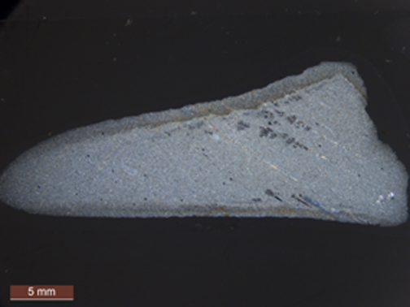

**Figure 24. Cross polarized light overview of Artifact type A.**

In hand specimen, sample Artifact type A is dark gray with a light grey weathered surface. The sample has a foliated texture composed of fine-grained (avg. dia. 27µm) elongated quartz, plagioclase, epidote, biotite, garnet and opaques (pyrite). Pyrite occurs in elongated masses parallel to foliation and as opaque intergranular areas. The sample contains weak laminations. The sample contains thin (<1mm) elongated (up to 6mm) irregular-shaped features composed exclusively of plagioclase and quartz occurring parallel to foliation. Unlike other samples, these features appear to be composed solely of quartz and feldspar. These features may represent fragments of fine-grained pumice lapilli or heterogeneity within the sediment source. This sample lacks distinctive features that allow it to be definitively volcanic or sedimentary. Based upon grain size, textures and mineralogy, this sample may be a metasiltstone. This sample has some features that correlate to those found at the Person County Quarry of Steponaitis et al (2006). None of the artifact samples contain the distinctive staining from pyrite. Some contain the elongate ovoid inclusions composed of plagioclase and quartz. The grain size and mineralogy of this sample is similar those found in the artifact samples and both artifact samples and this raw material contain the ovoid inclusions containing plagioclase and quartz.

Artifact Type B

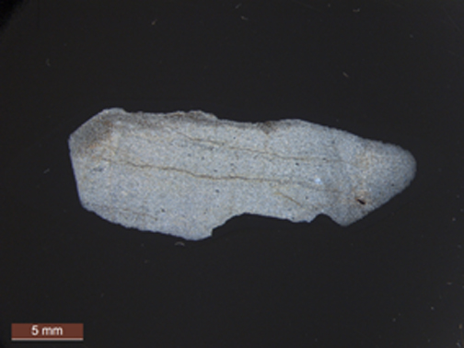

**Figure 25. Cross polarized light overview of Artifact type B.**

In hand specimen, Artifact type B is dark grey with a light grey weathered surface and contains laminations. The sample has a foliated fine-grained (avg. dia. 26µm) texture composed of quartz, epidote, green biotite, muscovite, garnet and opaque minerals. Foliation is oblique to relict laminations. The sample displays a single (<1mm) ovoid feature composed of quartz with minor epidote and muscovite. These ovoid features may represent possible pumice clasts heterogeneity in the sediment source prior to metamorphism. Subtle grain size changes parallel to laminae may represent graded bedding. The sample also shows oxidized layers parallel to foliation. Based on laminations, grain size changes (interpreted to be graded bedding), foliation and metamorphic mineralogy, this sample is a metasiltstone. Artifact type B has similar characteristics to rocks collected from the Person County, Chatham Pittsboro and Chatham Siler City Quarries of Steponaitis et al (2006). This raw material sample contains ovoid features and weakly developed graded bedding. These features were noted as being distinctive within samples from the Person Quarry (Stoddard in Steponaitis et al., 2006), however the micro-faults are lacking in this sample. Based upon these observations, this sample does not contain sufficient evidence to link it to one of the aforementioned quarries. Its sedimentary features and mineralogy are very similar to artifact samples 1, 3, and 5. None of these artifact samples contain the iron-stained, foliation fractures, however, this may have been a sample-specific characteristic avoided when selecting materials to quarry.

Artifact Type C

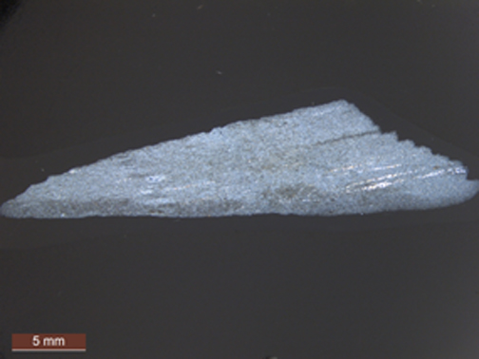

**Figure 26. Cross polarized light overview of Artifact type C.**

In hand specimen, Artifact type C is dark grey with darker grey laminations offset along small faults. The weathered exterior is light grey and shows dark banding. The sample has a foliated, fine-grained (avg. dia. 35µm) texture composed of elongated grains of quartz, epidote, clinozoisite, muscovite, green biotite, euhedral-subhedral garnet and opaques. The sample contains elongated, discontinuous quartz veins parallel to foliation. Laminations are oblique to foliation and offset along micro-faults. The sample contains small (~1mm x 2mm) ovoid features filled with quartz and epidote grains. The long axis of the features is parallel to laminations. These ovoid features may represent heterogeneity in the sediment source prior to metamorphism. Based upon laminations, foliation and metamorphic minerals, this sample is a metasiltstone. Laminations offset by micro-faults and ovoid features observed within this sample provide the strongest correlation to those described from the Person County Quarry of Steponaitis et al, (2006). These features are absent from the artifact samples. The grain size of this sample is slightly larger than those from the artifact sample suite and it does have the distinctive laminations. It is possible that due to the small sample size of the of artifact samples that the micro-faults and ovoid features were not sampled.

Artifact Type D (Fully Weathered)

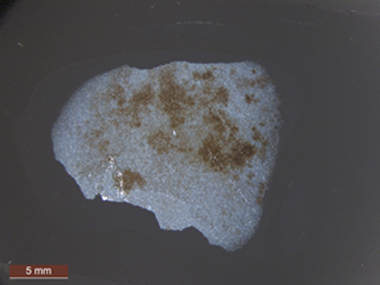

**Figure 27. Cross polarized light overview of Artifact type D.**

In hand specimen, artifact type D is light colored with a light grey weathered surface. In thin sections, the sample shows a foliated texture composed of fine-grained (avg. dia. 24µm) quartz, green biotite, muscovite, epidote, clinozoisite and garnet. The sample contains patches of iron-stained oxidized areas. The sample contains discontinuous thin veins of quartz that are parallel to foliation. The sample shows several small 1-2mm ovoid shaped patches of quartz crystals. Lack of definitive igneous or sedimentary textures and features makes the origin of this sample difficult to constrain. Based upon grain size, foliated texture and mineralogy, this sample may be a metasiltstone. This sample shares mineralogical similarities with all of the metasedimentary samples from this study, however it is significantly more weathered that others studied thus far. Based upon the weathering it can only be speculated this sample could be sourced form one of the other metasedimentary sample quarries from Person County, Chatham Siler City or the Chatham Pittsboro Quarry. Based on its weathering characteristics and lack of other diagnostic features, this raw material sample cannot be correlated to any of the artifact samples.

Artifact Type E

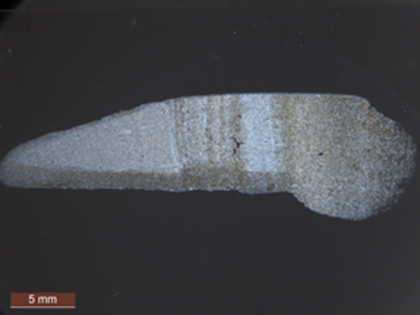

**Figure 28. Cross polarized light overview of Artifact type E.**

In hand specimen, artifact type E is light to dark grey and distinctively banded with a light grey weathered surface. The sample has slaty cleavage, contains laminations that are oblique to foliation. The sample is composed of fine-grained (avg. dia. 28µm) quartz, plagioclase, epidote, clinozoisite, green biotite, muscovite which are elongated and parallel to foliation. This sample also contains euhedral to subhedral garnets. Weak graded bedding is observed parallel to laminations. The sample shows a thin, foliation parallel, discontinuous quartz vein and minor offsets of laminae parallel to foliation. Based upon primary lamination, foliation and metamorphic mineralogy, this sample is a metasiltstone. This sample shares many characteristics in common with samples from the Person County quarry (Stoddard in Steponaitis et al., 2006). Based on the distinctive banding, it shows the greatest similarity with artifact sample 2. The grain size of this sample falls within the range of those from the artifact sample suite and it does have the distinctive laminations. It is possible due to the small sample size of the of artifact samples that the micro-faults and ovoid features were not sampled. Based on the distinctive banding, it shows the greatest similarity with artifact sample 2.

Artifact Type F

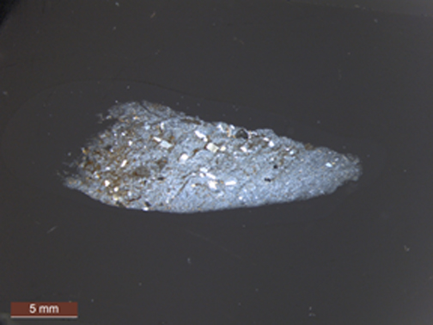

**Figure 29. Cross polarized light overview of Artifact type F.**

Artifact type F is light grey and crystalline in hand specimen. The sample has a foliated texture defined by parallel and planar arrangement of muscovite and epidote. Foliation overprints the primary porphyritic volcanic texture composed of larger (avg. dia. 663µm) phenocrysts of plagioclase feldspar, which constitute up to 7% of the sample. The sample contains quartz, epidote, muscovite and green biotite within its groundmass. The small sample size may misrepresent the phenocryst mineralogy. However, based upon the phenocryst mineralogy, this sample is a meta-trachyte. This sample may be best correlated with those from the Uwharries Western Quarry of Steponaitis et al (2006); however again, the small sample may bias the phenocrysts mineralogy. As with other volcanic samples within this suite, it does not provide a good match for the raw materials used in producing artifacts found at the site.

Artifact Type W

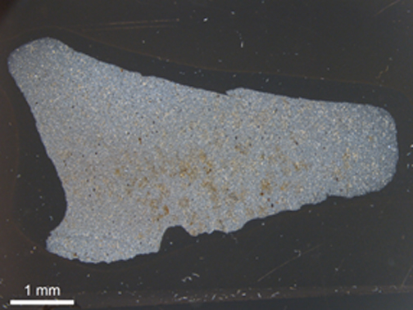

**Figure 30. Cross polarized light overview of Artifact type W.**

Artifact type W is dark grey with a distinctly speckled appearance on the exterior. Speckles occur as ~1mm diameter white clusters aligned parallel to foliation. The sample has a foliated texture composed of fine-grained (avg. dia. 26µm), subhedral quartz, plagioclase, epidote, clinozoisite, chlorite, abundant euhedral garnet and pyrite. In hand specimen view, the speckled areas are light colored and rounded. In cross-polarized light, these speckled areas are composed of clusters of chlorite, epidote and plagioclase. The speckled features may represent former amygdules representative of an ash deposit. Amygdules are holes (or vesicles) that are filled with other minerals subsequent to the original crystallization of volcanic rocks. The mineralogy of amygdules can vary. Based on this, the sample would be a metamorphosed ash-flow tuff. The speckled texture is unique and is not represent within the entire range of raw material samples and appears to be texturally similar to Artifact sample Y. This sample does not appear to be represented by any of the raw material samples collected from sites 31CD1398 and 1399. This sample may be best correlated to those from the Uwharries Western Quarry of Steponaitis et al., 2006.

Artifact Type X

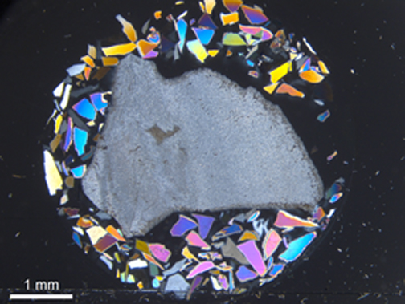

**Figure 31. Cross polarized light overview of Artifact type X.**

Artifact type X is light grey to tan and fine-grained in hand specimen. The sample is non-foliated and has a clastic texture, which shows relict bedding. Grain size changes are apparent in bedding. The sample is composed of fine-grained (avg. dia. 27µm) subhedral quartz, epidote, chlorite and opaques. Based on the bedding and grain size changes, this sample is a metasiltstone. The color of the hand specimen is different from other artifact samples, and the sample lacks the characteristic laminations seen in other artifact and raw material samples. This sample does not appear to be represented by any of the raw material samples collected from sites 31CD1398 and 1399. This sample may be best correlated to those from the Chatham Pittsboro or Chatham Siler City Quarry of Steponaitis et al., 2006.

Artifact Type Y

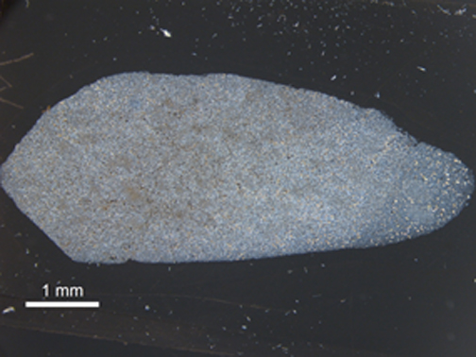

**Figure 32. Cross polarized light overview of Artifact type Y.**

Artifact type Y is light grey in hand specimen with light colored speckles (similar to type W). The sample has a foliated texture defined by planar arrangement of fine-grained (avg. dia. 22µm) quartz and epidote. The sample is composed of quartz, epidote, clinozoisite, biotite, garnet and chlorite. The sample contains rounded clusters of chlorite and quartz that are free of epidote. These may represent former amygdules. Based on this, the sample may represent a metamorphosed ash-flow tuff. Again, the exterior texture showing the amygdules is unique in comparison to any of the raw material samples. This sample does not appear to be represented by any of the raw material samples collected from sites 31CD1398 and 1399. This sample may be best correlated to those from the Uwharries Western Quarry of Steponaitis et al., 2006.

Artifact Type Z

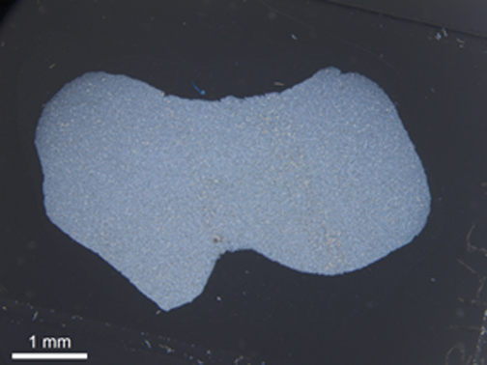

**Figure 33. Cross polarized light overview of Artifact type Z.**

Artifact type Z is light greyish-green and fine-grained in hand sample. Bedding is visible on the exterior of the sample. In thin section, artifact sample type Z is composed of fine-grained (avg. dia. 23µm) quartz, epidote, chlorite and biotite. The sample is weakly foliated oblique to bedding. Grain size changes occur within bedding. Based on the bedding and grain size changes, this sample is a metasiltstone. The color of the sample is distinct from all of the other artifact samples and the raw material samples collected from sites 31CD1398 and 1399. This sample lacks the laminations present in many of the artifact samples. This sample does not appear to be represented by any of the raw material samples collected from sites 31CD1398 and 1399. This sample may be best correlated to those from the Chatham Pittsboro or Chatham Siler City Quarry of Steponaitis et al., 2006.

Geochemistry

The compositions were measured by Michael Glascock using two analytical methods at the University of Missouri Archaeometry lab: X-ray fluorescence (XRF) and neutron activation analysis (NAA) utilizing the University of Missouri Research Reactor (MURR).

The metarhyolite samples arrived at MURR in July 2018. The samples arrived as solid chunks that required crushing, grinding and mixing prior to analysis. Using a Carver Press and 25 tons of pressure, about 15 grams from each rock was crushed into fragments smaller than five mm. The rock fragments were loaded into an alumina ceramic vessel along with a single 1 cm diameter alumina ball. A Spex Mixer-Mill performed the grinding and mixing. Previous research has demonstrated that an alumina ceramic mixing vessel induces the least possible contamination (Boulanger et al. 2013). After 20 minutes, the powder is typically <200 microns. The powders were stored in glass vials and placed in an oven at 100° C until ready for sample preparation.

X-Ray Fluorescence Analysis at MURR

A solution of Elvacite and acetone was prepared using 20 grams of Elvacite powder and 100 ml of acetone. The Elvacite solution was mixed with six grams of rock powder to make the rock powder mildly sticky after acetone evaporates without inducing a dilution effect. The Carver press was used produce a 32 mm diameter pellet (i.e. planchette) and about 4 mm thick from each sample.

All XRF measurements employed a ThermoScientific ARL Quantx energy-dispersive XRF spectrometer. The instrument has a rhodium-based X-ray tube and thermoelectrically-cooled silicon-drift detector (SDD). The tube was operated under two conditions to measure the major constituents.

1. Low Za, 120 seconds, no filter, 4kV, with vacuum to measure Na, Mg, Al, Si, P, and S.

2. Low Zc, 60 seconds, aluminum filter, 12 kV, in air to measure K, Ca, Ti, Mn, and Fe.

Calibration of the Quantx XRF was performed by measuring a set of 40 rock and clay standards obtained from the National Institute of Standards and Technology, United States Geological Survey, and the Geological Survey of Japan.

ED-XRF relies on the area under the Compton scattering peak as a proxy for the mass of sample analyzed. By dividing the areas for peaks from the various elements by the Compton peak, concentrations are calculated. However, the method is imperfect for small and thin artifacts, due to the loss of Compton events. In this study, all planchette samples were considered relatively thick. For most elements measured by ED-XRF, the uncertainties are <7%.

Neutron Activation Analysis at MURR

The sample powders were prepared for NAA following procedures described elsewhere (Glascock 1992) by weighing two samples into vials. For the short-lived elements, 150 mg of powder was weighed into clean high-density polyvials. For the long-lived elements, 200 mg of powder was weighed into high-purity quartz vials. Standard made from SRM-1633b Flyash, SRM-688 Basalt Rock, and SRM-278 Obsidian Rock was similarly prepared.

The short-lived elements were measured using a five-second irradiation in a neutron flux of 8x1013 neutrons cm-2 s-1, followed by a decay time of 25 minutes, and measurement time of 12 minutes with a high-purity germanium detector. The short-lived elements measured were Na, Al, K, Ca, Ti, V, Mn, and Dy.

The long-lived elements were measured using a 24-hour irradiation in a neutron flux of 5x1013 neutrons cm-2 s-1, followed by two separate measurements. The first measurement occurs seven days after the end of irradiation using a 30-minute count time to measure: As, Ba, La, Nd, Sm, Yb, Lu, and U. The second measurement occurs between 22-28 days after the end of irradiation using 2.5 hours counting times to measure: Sc, Cr, Fe, Co, Ni, Zn, Rb, Sr, Zr, Sb, Cs, Ce, Eu, Tb, Hf, Ta, and Th. For most elements by NAA, the uncertainties are <3%.

Protolith interpretation is based on geochemical signatures of major and trace elements. In a plot of total alkali elements vs. silica (TAS), the bulk rock composition (indicative of mineralogy) as measured by XRF, plots within the field of rhyolites and dacite similar to the protoliths suggested by Stoddard (*in* Steponaitis et al., 2006). Using the XRF data, normative analysis was used to calculate hypothetical mineral assemblages. Results from normative analysis are classified using the IUGS classification for volcanic rocks and differ from naming conventions used in the total alkali vs. Si diagram. The TAS classification does not account for the dispersion of Si into individual mineral phases as predicted by the normative analysis. Rock names reported here follow the convention of Stoddard (in Steponaitis et al., 2006) using IUGS field name combined with normative data in the case of metavolcanic rocks and IUGS normative name based on petrographic characteristics from thin section descriptions for metasedimentary rocks devoid of volcanic textures and features. Our results for the XRF samples are reported in Table 2.

Trace element spider diagrams (chondrite normalized and primitive mantle normalized) show similarities of samples consistent with rhyolitic and dacitic protoliths. Because samples are interpreted to represent metamorphosed siliciclastic rocks derived from weathering of pre-existing volcanic, variation in TAS compositions (within rhyolites) may reflect mixing in sediment sources. The dacitic sample appears to represent a distinct source.

|  |  |  |  |  |  |  |  |  |  |  |  |
| --- | --- | --- | --- | --- | --- | --- | --- | --- | --- | --- | --- |
| **ANID** | **Na2O** | **MgO** | **Al2O3** | **SiO2** | **P2O5** | **SO3** | **K2O** | **CaO** | **TiO2** | **MnO** | **Fe2O3** |
|  | **%** | **%** | **%** | **%** | **%** | **%** | **%** | **%** | **%** | **%** | **%** |
| AEC001 FS115-RM06 | 3.59 | 0.66 | 13.42 | 75.82 | 0.14 | 0.00 | 2.31 | 1.69 | 0.22 | 0.09 | 2.07 |
| AEC002 FS116-RM07 | 3.84 | 0.62 | 11.88 | 77.04 | 0.00 | 0.00 | 2.38 | 1.61 | 0.22 | 0.12 | 2.29 |
| AEC003 FS454-RM10 | 3.88 | 0.47 | 12.54 | 77.89 | 0.00 | 0.00 | 2.99 | 0.57 | 0.20 | 0.08 | 1.37 |
| AEC004 FS453-RM13 | 5.22 | 1.98 | 13.65 | 67.45 | 0.23 | 0.00 | 1.15 | 3.90 | 0.52 | 0.20 | 5.71 |
| AEC005 FS455-RM14 | 0.70 | 0.79 | 11.40 | 78.16 | 0.07 | 0.00 | 1.84 | 4.11 | 0.32 | 0.12 | 2.50 |
| AEC006 Type A | 5.77 | 0.49 | 11.73 | 77.19 | 0.00 | 0.00 | 1.70 | 1.29 | 0.15 | 0.08 | 1.61 |
| AEC007 Type B | 5.32 | 0.53 | 11.61 | 77.46 | 0.00 | 0.00 | 2.28 | 0.76 | 0.17 | 0.09 | 1.78 |
| AEC008 Type C | 6.82 | 0.54 | 13.03 | 75.05 | 0.00 | 0.00 | 1.74 | 0.98 | 0.15 | 0.09 | 1.61 |
| AEC009 Type E | 4.16 | 0.55 | 11.27 | 78.42 | 0.00 | 0.00 | 1.70 | 1.28 | 0.20 | 0.12 | 2.28 |
| AEC010 Type F | 6.67 | 0.56 | 14.02 | 73.70 | 0.00 | 0.00 | 1.46 | 1.50 | 0.24 | 0.10 | 1.75 |
| AEC011 FS457-RM-16 | 6.14 | 0.57 | 14.04 | 73.52 | 0.06 | 0.00 | 2.48 | 0.93 | 0.20 | 0.09 | 1.98 |
| AEC012 FS265-RM9 | 5.85 | 0.50 | 11.46 | 77.77 | 0.00 | 0.00 | 1.37 | 1.23 | 0.16 | 0.08 | 1.60 |

**Table 2. XRF results from MUUR**

**Table 2. XRF results from MUUR**

**Table 2. XRF results from MUUR**

**Figure 34. Plot of total alkalis vs. silica shows samples fall within rhyolite (AEC001-003, AEC 005-012)**

**and dacite (AEC004) fields.**

**Figure 35. IUGS Classification for Volcanic rocks (after Winter, 2001)**

|  |  |  |  |  |  |  |  |
| --- | --- | --- | --- | --- | --- | --- | --- |
| **ANID** | **FS#** | **Normative Values** | | | **IUGS Field/Petro name** | **IUGS Norm Name** | **TAS Name** |
| **Q/QAP** | **A/QAP** | **P/QAP** |
| AEC001 | FS115-RM6 | 43.88 | 15.23 | 40.89 | Dacite | Dacite | Rhyolite |
| AEC002 | FS116-RM7 | 41.83 | 15.39 | 42.78 | Dacite | Dacite | Rhyolite |
| AEC003 | FS454-RM10 | 43.13 | 19.18 | 37.69 | Metasiltstone | Dacite | Rhyolite |
| AEC004 | FS453-RM13 | 24.27 | 8.63 | 67.10 | Dacite | Andesite | Dacite |
| AEC005 | FS455-RM14 | 60.51 | 12.22 | 27.28 | Metasiltstone | Dacite | Rhyolite |
| AEC006 | Type A (A.) | 35.63 | 11.00 | 53.37 | Metasiltstone | Dacite | Rhyolite |
| AEC007 | Type B (A.) | 36.48 | 14.63 | 48.89 | Metasiltstone | Dacite | Rhyolite |
| AEC008 | Type C (A.) | 27.30 | 11.27 | 61.43 | Metasiltstone | Dacite | Rhyolite |
| ATEC009 | Type E (A.) | 44.95 | 11.01 | 44.04 | Metasiltstone | Dacite | Rhyolite |
| AEC010 | Type F (A.) | 26.24 | 9.42 | 64.34 | Dacite | Dacite | Rhyolite |
| AEC011 | FS457-RM16 | 25.64 | 15.88 | 58.48 | Metasiltstone | Andesite/Dacite | Rhyolite |
| AEC012 | FS265-RM9 | 37.23 | 8.84 | 53.93 | Metasiltstone | Dacite | Rhyolite |

**Table 3. Data from normative analysis and rocks names based upon classification from XRF Analyses.**

|  |  |  |  |  |  |  |  |  |  |  |  |  |  |  |  |  |
| --- | --- | --- | --- | --- | --- | --- | --- | --- | --- | --- | --- | --- | --- | --- | --- | --- |
| (ppm) | **Na** | **Al** | **K** | **Ca** | **Sc** | **Ti** | **V** | **Cr** | **Mn** | **Fe** | **Co** | **Ni** | **Zn** | **As** | **Rb** | **Sr** |
| AEC001 | 22578 | 70036 | 18131 | 12358 | 6.14 | 1368 | 5.88 | 7.45 | 522 | 13621 | 1.37 | 0.00 | 38.0 | 0.94 | 93.7 | 80.6 |
| AEC002 | 25337 | 70140 | 22602 | 12492 | 7.60 | 1277 | 14.61 | 7.03 | 713 | 16330 | 2.24 | 0.00 | 62.0 | 1.16 | 79.7 | 101.7 |
| AEC003 | 27223 | 69101 | 30044 | 4885 | 8.62 | 1709 | 8.33 | 3.95 | 452 | 8960 | 1.01 | 0.00 | 36.5 | 1.44 | 77.9 | 104.1 |
| AEC004 | 34018 | 75588 | 7725 | 26786 | 21.52 | 4027 | 115.72 | 38.46 | 1194 | 41149 | 14.23 | 0.00 | 76.0 | 8.96 | 35.8 | 139.6 |
| AEC005 | 9271 | 63962 | 15194 | 29888 | 12.61 | 2275 | 26.04 | 2.66 | 745 | 18545 | 2.02 | 0.00 | 79.4 | 2.39 | 80.2 | 238.8 |
| AEC006 | 42018 | 71020 | 17017 | 9029 | 7.90 | 652 | 0.00 | 1.71 | 562 | 10198 | 0.80 | 0.00 | 21.4 | 4.58 | 46.2 | 200.5 |
| AEC007 | 36768 | 72315 | 19075 | 6557 | 9.29 | 1022 | 0.00 | 1.37 | 576 | 11927 | 0.95 | 0.00 | 38.8 | 0.86 | 65.9 | 126.7 |
| AEC008 | 45289 | 75204 | 14003 | 7669 | 7.27 | 422 | 0.00 | 7.57 | 493 | 10459 | 0.82 | 0.00 | 28.2 | 1.91 | 50.1 | 156.6 |
| AEC009 | 31059 | 64748 | 16869 | 10337 | 9.28 | 1149 | 11.66 | 3.26 | 872 | 15493 | 2.73 | 0.00 | 32.0 | 1.55 | 46.6 | 168.1 |
| AEC010 | 41841 | 81677 | 14417 | 11161 | 9.91 | 1285 | 20.47 | 2.14 | 568 | 11575 | 1.51 | 0.00 | 34.8 | 2.20 | 37.0 | 180.2 |
| AEC011 | 42474 | 83961 | 20856 | 6636 | 9.94 | 989 | 12.31 | 9.58 | 654 | 13274 | 1.27 | 0.00 | 38.9 | 2.09 | 78.8 | 128.1 |
| AEC012 | 42935 | 71140 | 11817 | 9995 | 8.76 | 1013 | 0.00 | 6.10 | 504 | 10152 | 0.88 | 0.00 | 14.6 | 2.58 | 34.6 | 207.6 |

|  |  |  |  |  |  |  |  |  |  |  |  |  |  |  |  |  |  |
| --- | --- | --- | --- | --- | --- | --- | --- | --- | --- | --- | --- | --- | --- | --- | --- | --- | --- |
| (ppm) | **Zr** | **Sb** | **Cs** | **Ba** | **La** | **Ce** | **Nd** | **Sm** | **Eu** | **Tb** | **Dy** | **Yb** | **Lu** | **Hf** | **Ta** | **Th** | **U** |
| AEC001 | 97.3 | 0.54 | 1.41 | 467 | 17.4 | 35.9 | 17.3 | 3.78 | 1.01 | 0.58 | 3.76 | 2.84 | 0.35 | 4.05 | 0.45 | 5.13 | 1.53 |
| AEC002 | 147.5 | 0.23 | 1.03 | 519 | 21.4 | 45.9 | 19.9 | 4.71 | 1.17 | 0.70 | 4.84 | 3.60 | 0.48 | 5.40 | 0.60 | 6.81 | 1.55 |
| AEC003 | 115.0 | 0.22 | 1.35 | 685 | 18.2 | 38.1 | 17.1 | 4.09 | 0.78 | 0.65 | 4.81 | 3.81 | 0.52 | 5.49 | 0.69 | 8.34 | 2.47 |
| AEC004 | 118.0 | 0.50 | 4.81 | 279 | 17.1 | 35.3 | 13.5 | 4.03 | 1.28 | 0.61 | 4.18 | 2.83 | 0.37 | 4.51 | 0.43 | 4.30 | 1.25 |
| AEC005 | 148.5 | 0.52 | 1.78 | 396 | 25.7 | 54.7 | 26.8 | 6.15 | 1.36 | 0.95 | 6.32 | 4.28 | 0.56 | 5.73 | 0.61 | 7.61 | 2.23 |
| AEC006 | 97.3 | 0.43 | 0.40 | 416 | 23.4 | 49.3 | 21.4 | 5.17 | 0.99 | 0.81 | 5.11 | 3.69 | 0.48 | 4.52 | 0.58 | 6.92 | 2.13 |
| AEC007 | 121.1 | 0.20 | 0.64 | 586 | 25.7 | 54.4 | 24.2 | 5.94 | 1.13 | 0.95 | 6.02 | 4.13 | 0.56 | 5.15 | 0.63 | 7.22 | 1.78 |
| AEC008 | 96.7 | 0.33 | 0.49 | 460 | 20.3 | 43.5 | 20.9 | 4.55 | 0.87 | 0.70 | 4.77 | 3.25 | 0.44 | 4.32 | 0.57 | 6.63 | 1.82 |
| AEC009 | 108.6 | 0.30 | 0.98 | 480 | 20.6 | 43.7 | 20.8 | 4.89 | 0.99 | 0.75 | 5.53 | 3.94 | 0.55 | 5.09 | 0.57 | 7.06 | 1.90 |
| AEC010 | 134.1 | 0.36 | 1.23 | 387 | 26.1 | 57.2 | 26.2 | 5.92 | 1.19 | 0.90 | 6.05 | 4.49 | 0.60 | 6.61 | 0.75 | 8.22 | 2.27 |
| AEC011 | 158.5 | 0.18 | 1.54 | 658 | 27.4 | 58.1 | 27.2 | 6.12 | 1.12 | 0.91 | 6.01 | 4.48 | 0.62 | 6.04 | 0.75 | 8.39 | 2.24 |
| AEC012 | 108.4 | 0.32 | 0.39 | 398 | 25.7 | 53.9 | 24.6 | 5.66 | 1.01 | 0.90 | 5.75 | 3.92 | 0.52 | 5.08 | 0.63 | 7.76 | 1.53 |

**Table 4. Concentration of elements measured by INAA.**

**Figure 36. Chondrite normalized plot of trace element signatures within samples.**

**Figure 37. Primitive mantle normalized plot of trace elements from samples suggestive of**

**lithologies similar to rhyolites and dacites.**

We utilized the bivariate plots of trace element compositions, from Glascock and Speakman (*in* Steponaitis et al, 2006), to compare samples from this study to those from source area quarries of raw materials and artifacts from Steponaitis et al., 2006). The raw materials and artifacts in this study sample a distinct location not reported in the Steponaitis et al report. Samples in this study have compositions that are distinct from quarry samples of the Chatham 2 (Chatham Silk Hope), Cumberland, Durham and Uwharrie 2 Quarries do not appear to be represented by the raw material samples in this study. Based on where samples fall within the ellipses (representative of 90% confidence intervals for samples membership within a source area group), samples: AEC002, FS454-RM10, RM9 Type B, RM9 Type C, RM9 Type E, RM9 Type F, FS457-RM16, FS265-RM9 have trace element signatures similar to samples from the Uwharrie 1 Quarry (Uwharrie Eastern, Western, South, Southeastern) and Chatham 1 detailed by Stepoinaitis et al. (2006). Sample AEC005 has a trace element signature that has affinities to both the Chatham 1 and Uwharrie 1 quarries. RM9 Type A has a trace element signature that shares affinities with samples from the Chatham 1, Person and Uwharrie 1 quarries. Samples 001 and FS453-RM13 had a signature that was distinct to the Chatham 1 Quarry.

**Figure 38. Bivariate plot of log concentrations of Zr vs. La showing source quarries (symbols) surrounded by ellipses representing 90% confidence interval of potential membership to source quarries. Samples from this study occur as colored symbols (modified from Steponaitis et al., 2006).**

**Figure 39. Bivariate plot of log concentrations of Ta vs. Hf showing source quarries (symbols) surrounded by ellipses representing 90% confidence interval of potential membership to source quarries. Samples from this study occur as colored symbols (modified from Steponaitis et al., 2006).**

**Figure 40. Bivariate plot of log concentrations of Rb vs. Eu showing source quarries (symbols) surrounded by ellipses representing 90% confidence interval of potential membership to source quarries. Samples from this study occur as colored symbols (modified from Steponaitis et al., 2006).**

**Figure 41. Bivariate plot of log concentrations of Ta vs. Fe showing source quarries (symbols) surrounded by ellipses representing 90% confidence interval of potential membership to source quarries. Samples from this study occur as colored symbols (modified from Steponaitis et al., 2006).**

**Figure 42. Bivariate plot of log concentrations of Th vs. Cs showing source quarries (symbols) surrounded by ellipses representing 90% confidence interval of potential membership to source quarries. Samples from this study occur as colored symbols (modified from Steponaitis et al., 2006).**

Michael Glascock (personal communication, 2019) used PCA and Mahalanobis distance probabilities to assess the potential membership of samples analyzed by INAA to membership in source quarry groups. The Fort Bragg Lithics (FBL) source groups as assigned by Steponaitis were combined with the 12 AEC samples. Due to missing values, six elements were eliminated – Ni, Cr, As, V, Sr, and U. In order to asses samples membership with a potential source area, a new principle component analysis was performed using the bulk composition data from the FBL samples in Steponaitis et al., 2006 and AEC samples.

New principle components projected the AEC samples against the FBL source groups as identified in the report by Steponaitis et al., (2006). Because some of the groups were small, the first four principle components were used to explain about 85% of the variance in the dataset.

Based on the Mahalanobis distance probabilities below, the Chatham-1 source is most similar to almost all of the artifacts analyzed by INAA. AEC004 is clearly not similar to Chatham-1 and may be related to samples from the Person Quarry.

|  |  |  |  |  |  |  |  |  |
| --- | --- | --- | --- | --- | --- | --- | --- | --- |
| **ANID** | **FS#** | **CHATHAM-1** | **DURHAM** | **ORANGE** | **PERSON** | **UWHARRIES-1** | **UWHARRIES-2** | **Best Group** |
| AEC001 | FS115-RM6 | **63.344** | 8.996 | 0.117 | 5.735 | 0.425 | 43.730 | **CHATH-1** |
| AEC002 | FS116-RM7 | **88.705** | 16.484 | 0.119 | 14.899 | 0.311 | 48.638 | **CHATH-1** |
| AEC003 | FS454-RM10 | **66.315** | 11.987 | 0.120 | 6.380 | 4.270 | 46.891 | **CHATH-1** |
| AEC004 | FS453-RM13 | 53.292 | 41.486 | 0.021 | **60.306** | 0.000 | 34.151 | **PERSON** |
| AEC005 | FS455-RM14 | **70.231** | 9.716 | 0.122 | 13.323 | 0.189 | 23.763 | **CHATH-1** |
| AEC006 | Type A (A.) | **37.178** | 16.970 | 2.793 | 9.213 | 9.568 | 32.611 | **CHATH-1** |
| AEC007 | Type B (A.) | **51.528** | 19.020 | 0.651 | 14.246 | 6.901 | 37.806 | **CHATH-1** |
| AEC008 | Type C (A.) | 30.275 | 20.922 | 18.401 | 9.407 | 7.532 | **47.765** | **UWHAR-2** |
| AEC009 | Type E (A.) | **76.106** | 26.522 | 0.148 | 26.176 | 0.084 | 63.014 | **CHATH-1** |
| AEC010 | Type F (A.) | **72.295** | 17.389 | 1.767 | 21.684 | 2.739 | 26.166 | **CHATH-1** |
| AEC011 | FS457-RM16 | **70.107** | 14.015 | 0.165 | 15.980 | 2.003 | 27.762 | **CHATH-1** |
| AEC012 | FS265-RM9 | 30.584 | 26.313 | 1.142 | 16.277 | 4.004 | **36.368** | **UWHAR-2** |

**Table 5. Membership probabilities (%) for samples in group: NAA-AECOM**

**Probabilities calculated by projecting unknowns against reference groups.**

Conclusions

Samples collected in this study lie within the CZUfc unit of the Uwharrie formation (Sieders, 1981) which is mapped as a variety of felsic volcaniclastic rocks. The Uwharrie and overlaying Tillery formations provide the best lithological similarities to samples collected from these sites. The 1985 geologic map shows the Uwharrie and Tillery formations are also exposed within the Chatham 1, Person and Uwharries 2 quarry regions detailed by the Steponaitis report.

Petrographic study of the samples collected from sites 31CD1398 and 31CD1399 show a heterogeneous mixture of metavolcanics and metasedimentary lithologies from Uwharrie formation. Geochemical study of a subset of these samples shows they have similar major element compositions to rhyolitic and dacitic samples detailed in the Steponaitis et al (2006) report. Normative analysis of samples in this study shows they are or have provenance to rhyolitic to dacitic volcaniclastic and metasedimentary rocks.

Trace element compositions of samples from sites 31CD1398 and 31CD1399 indicate there are chemical similarities to samples from many of the quarries detailed within the Steponaitis et al (2006) report, but they do show some variation in their composition. The petrology of raw material samples from Sites 31CD1398 and 31CD1398 indicate that they are from similar metavolcanic rock types with a distinct geochemical composition.

Source quarries in the Steponaitis report sample distinct chemical compositions associated with the metasedimentary and metavolcanic samples in these regions. Samples detailed in this study appear to sample interbedded or distinct units within a heterogeneous unit of the Uwharrie formation. The composition of the lithologies of sampled from Sites 31CD1398 and 31CD1399 are similar to those detailed in the Steponaitis report. However, these samples have a trace element composition that is distinct from the samples collected in the previous study.

The trace element composition of metavolcanic rocks within the Uwharrie and overlaying Tillery formations appears to vary across the Carolina Terrain. Sites 31RD1398 and 31RD13999 have a similar petrology to other locations studied, but a slightly different trace element composition.

###### References

Birkeland, P.W.

1999 *Soils and Geomorphology*, 3rd Ed. Oxford University Press, New York. 430 pp.

[Cowan, Ellen A.](mailto:cowanea@appstate.edu), Seramur, Keith C. and Marshall, Scott T., 2015, Upstream Terraces on the New River in North Carolina: Illusive Landforms with a Climate History. Abstracts with Programs, 64th Annual Meeting Southeastern Section Geological Society of America.

Daniel, I.R, and Butler, J.R., 1996. An archaeological survey and petrographic description of rhyolite

sources in the Uwharrie Mountains, North Carolina. Southern Indian Studies, V.45. pp. 1-37.

Delcourt, Hazel R., and Paul A. Delcourt

1985 Quaternary Palynology and Vegetational History of the Southeastern United States. In *Pollen Records of Late-Quaternary North American Sediments*, edited by Vaughn .M. Bryant, Jr. and Richard G. Holloway, pp. 1-37. American Association of Stratigraphic Palynologists Foundation, Dallas

Folk, R.L.

1980 *Petrology of Sedimentary Rocks*, Austin, Texas, Hemphill's Book Store.

Leigh, D.S., 2006. Terminal Pleistocene braided to meandering transition in rivers of the Southeastern

USA. Catena, v. 66, p. 155-160.

Schoeneberger, P.J., D.A. Wysocki, E.C. Benham, and W.D. Broderson

1998 *Field Book for Describing and Sampling Soils*. Natural Resources Conservation Service, U.S. Dept. of Agriculture, National Soil Survey Center, Lincoln.

Sieders, V.M. 1981 Geologic Map of the Asheboro, North Carolina, and Adjacent Areas. NC

Geological Survey Miscellaneous Investigations Map I-1314.

Steponaitis, V.P., McReynolds, T.E., Irwin, J.D. and Moore, C.D. Eds. 2006. Stone Quarries in the

Carolina Slate Belt. Research Laboratories in Archaeology, UNC.

U.S. Dept. of Agriculture

2019 Web Soil Survey, Natural Resources Conservation Service, Randolph County NC.

Winter, J.D., 2001 An Introduction to Igneous and Metamorphic Petrology. Prentice Hall, Upper

Saddle River, N.J.